
INDUSTRY REPORT
Global Investment Banking & Brokerage
Jan 2026

About

IBISWorld
IBISWorld specializes in industry research with coverage on thousands of global industries. Our comprehensive data and in-depth analysis help businesses of all types gain quick and actionable insights on industries around the world. Busy professionals can spend less time researching and preparing for meetings, and more time focused on making strategic business decisions.

Table Of Contents | Standard

1. About 4
Codes 4
Definition 4
Related Terms 4
What's Included 4
Companies 5
Related Industries 5
Additional Resources 5
2. At a Glance 6
Key Takeaways 6
Products and Services 7
Major Players 8
Key External Drivers 9
Industry Structure 9
SWOT 10
Executive Summary 10
3. Performance 11
Highlights 11
Key Takeaways 11
Performance Snapshot 12
Outlook 20
Life Cycle 22
4. Products and Markets 23
Key Takeaways 23
Products and Services 23
Major Markets 28
International Trade 30
5. Geographic Breakdown 31
Key Takeaways 31
Business Locations 32
6. Competitive Forces 34
Key Takeaways 34
Concentration 34
Barriers to Entry 35
Substitutes 36
Buyer & Supplier Power 37
7. Companies 39
Key Takeaways 39
Market Share 40
Companies 41
8. External Environment 52
Key Takeaways 52
External Drivers 52
Regulation & Policy 55
Assistance 56
9. Financial Benchmarks 57
Key Takeaways 57
Cost Structure 57
Key Ratios 60
10. Key Statistics 62
Industry Data 62

1. About
https://my.ibisworld.com/gl/en/industry/J5521-GL/about

Codes

Definition
This industry covers global investment banking and brokerage activities. Operators provide a diverse range of securities services, including investment banking and broker-dealer services. Operators also offer banking and asset management services and engage in proprietary trading, such as trading their own capital for a profit.

Related Terms

TIER 1 CAPITAL
Secure and transparent core capital comprising equity capital and disclosed reserves.

VOLCKER RULE
A specific section of the Dodd-Frank Wall Street Reform and Consumer Protection Act that restricts US banks from making certain kinds of speculative investments that do not benefit their customers.

MARKET-MAKING
The decision to buy, sell or otherwise transact with customers for a specific security. Revenue is generated through the difference between buy and sell prices on transactions.

LEVERAGING
Investing with borrowed money, which can increase potential gains, but also risks greater losses.

BOUTIQUES
Smaller-sized investment banking enterprises that usually focus on a few services, usually advisory services, and do not have many employees.

BULGE BRACKET
Large banks that offer a full breadth of financial services and are involved in other financial industries such as commercial banking.

What's Included
- Underwriting, originating or maintaining markets for securities issuance
- Principal and proprietary trading
- Providing corporate strategy advisory services
- Providing corporate finance services

Companies
- JPMorgan Chase & Co.
- Citigroup Inc.
- Goldman Sachs Group Inc.
- Morgan Stanley
- Bank of America Corporation
- Deutsche Bank AG

Related Industries

Industries in the Same Sector
- Competitors:
  - Global Pension Funds
- Complementors:
  - Global Commercial Banks
  - Global Life & Health Insurance Carriers
  - Global Reinsurance Carriers

International Industries
- Securities Brokering in the US
- Investment Banking & Securities Intermediation in the US
- Investment Banking and Securities Brokerage in Australia
- Financial Asset Broking Services in New Zealand
- Security & Commodity Contracts Brokerage in the UK
- Securities Brokerage and Transaction Services in China

Additional Resources
- Securities Industry and Financial Markets Association
- US Federal Reserve
- Refinitiv
- Global Financial Markets Association

2. At a Glance
https://my.ibisworld.com/gl/en/industry/J5521-GL/at-a-glance
Revenue  $410.2bn  ’20-’25 ↑ 1.7 %  ’25-’30 ↑ 1.8 % | Employees  230k  ’20-’25 ↓ 0.3 %  ’25-’30 ↑ 1.4 % | Businesses  23,274  ’20-’25 ↓ 2.6 %  ’25-’30 ↑ 0.7 %
Profit  $142.7bn  ’20-’25 ↑ 4.0 % | Profit Margin  34.8%  ’20-’25 ↑ 3.6 pp | Wages  $104.9bn  ’20-’25 ↓ 0.5 %  ’25-’30 ↑ 1.5 %

Key Takeaways

Performance
- Volatility in financial markets primarily stems from investor uncertainty. Increased volatility in financial markets has led to increased trading and investment-grade debt activity for companies.
- Investment banks provide their customers with debt underwriting. Governments and businesses are looking to finance their operations by offering debt to various investors through the industry's underwriting services.

Products and Markets
- Debt underwriting’s share of industry revenue has increased. Investment banks serve as the middlemen between companies looking to raise funds by securitizing a company’s ownership or debt to be traded to investors in exchange for capital.
- Investment banks and securities dealers provide corporate finance services. However, regulatory and technological changes over the past decade blurred the lines between products offered by businesses and other financial services companies.

Products and Services
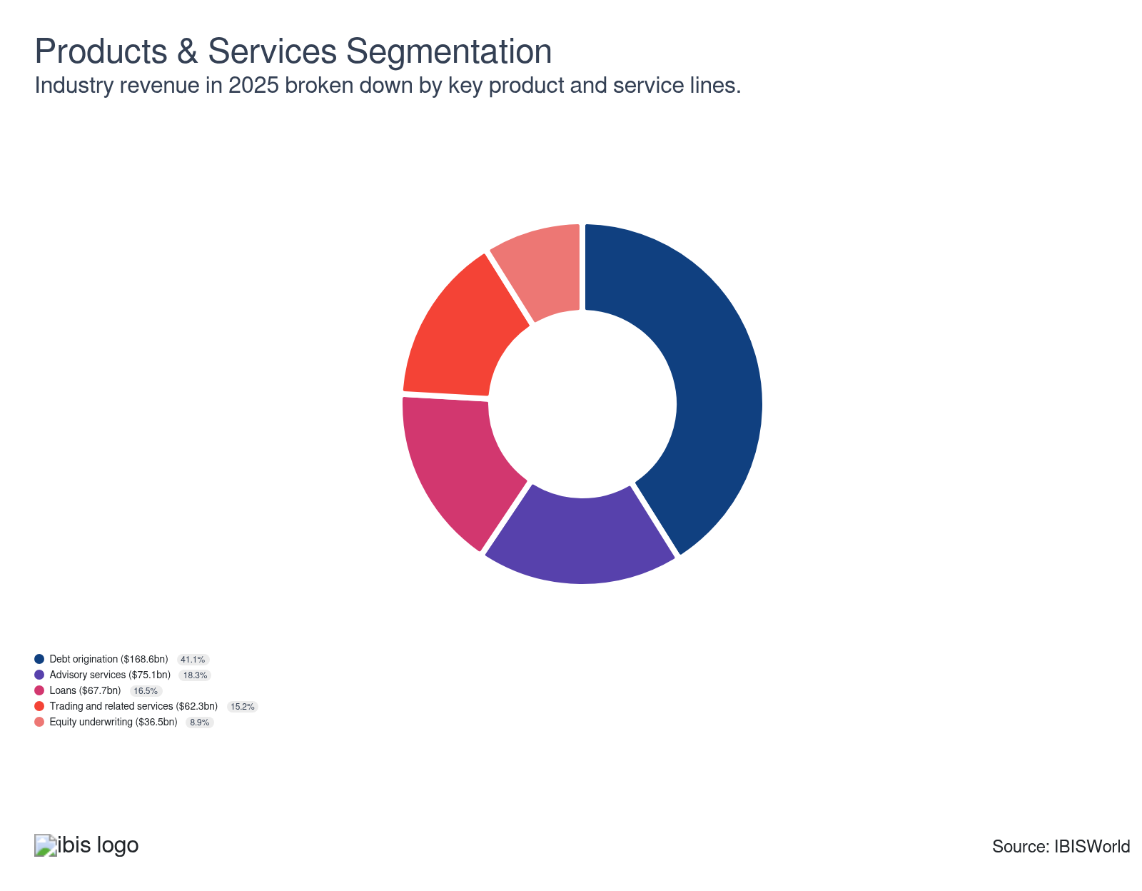

Major Players
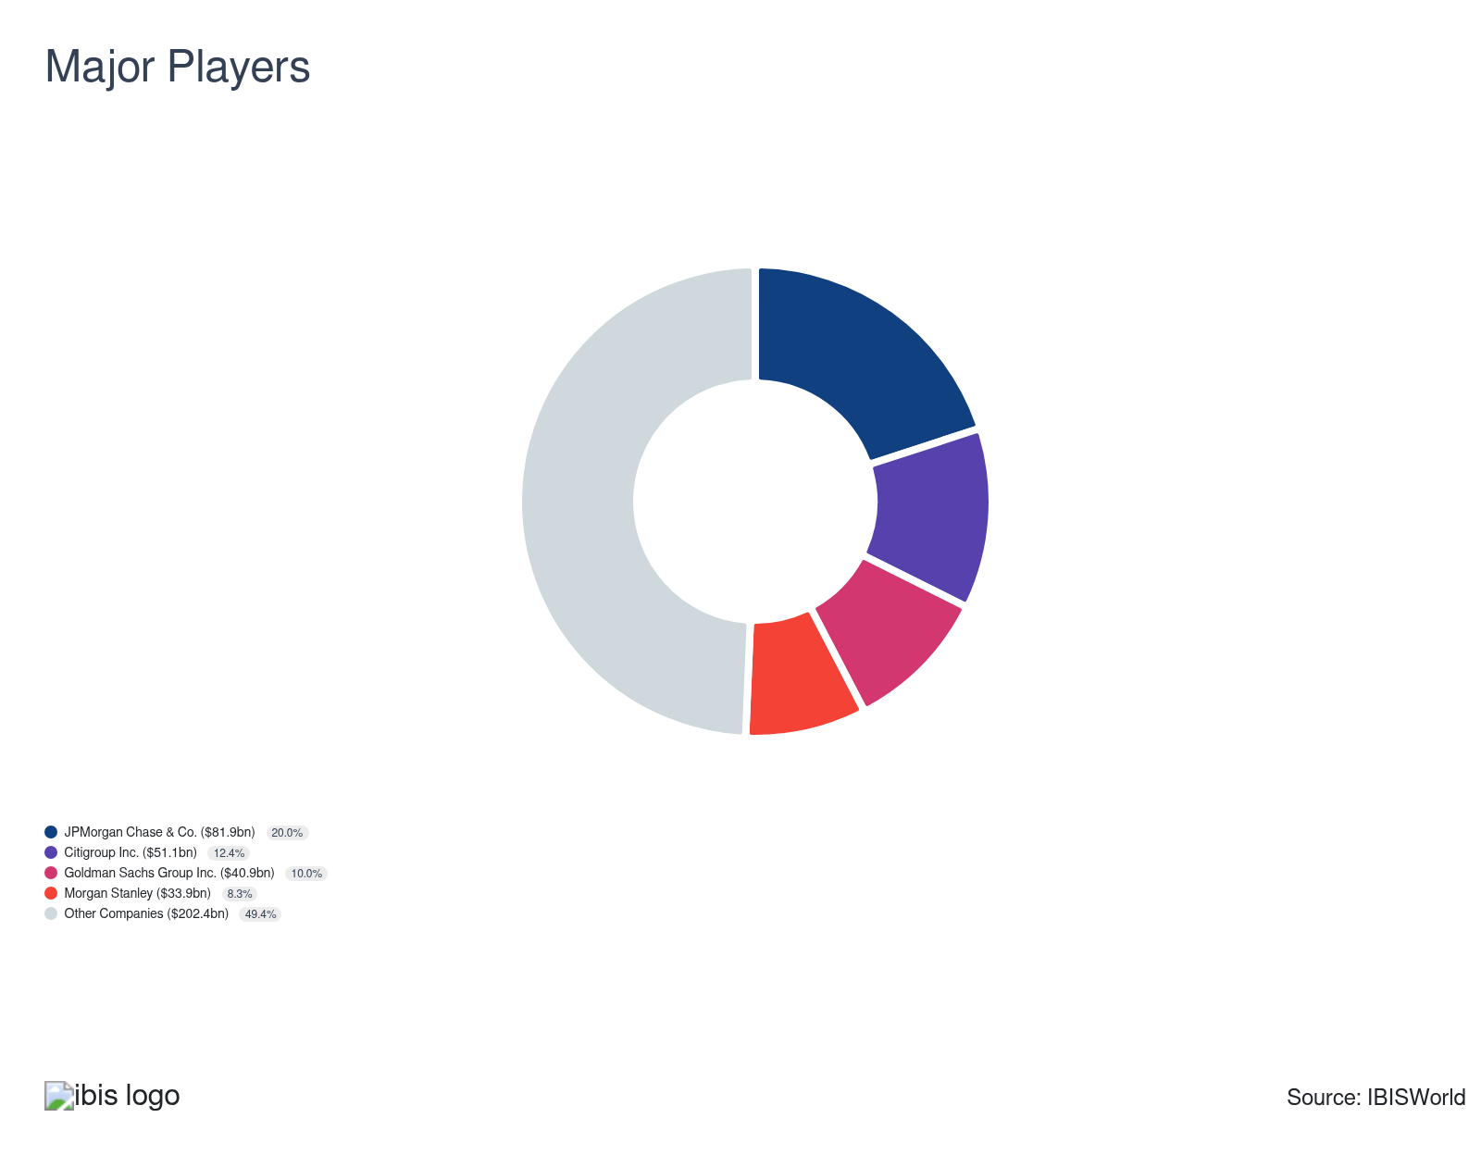

Key External Drivers
Key External Drivers | Impact
Global investor confidence | Positive
MSCI World Index | Positive
LIBOR - London Interbank Offered Rate | Positive
Industrial production index of OECD countries | Positive

Industry Structure
Characteristic | Level | Trend
Concentration | Moderate
Barriers To Entry | High | Increasing
Regulation and Policy | High | Steady
Life Cycle | Mature
Revenue Volatility | High
Assistance | Moderate | Steady
Competition | High | Increasing
Innovation | Moderate

SWOT
Strengths  High Profit vs. Sector Average  Low Product/Service Concentration  High Revenue per Employee  Low Capital Requirements | Weaknesses  High Volatility  High Customer Class Concentration | Opportunities  High Revenue Growth (2019-2024)  High Performance Drivers  LIBOR - London Interbank Offered Rate | Threats  Low Outlier Growth  Low Revenue Growth (2024-2029)  MSCI World Index

Executive Summary

Good investment: Rising advisory service revenue will drive industry revenue growth
The global investment bankers and brokerage industry is expected to perform well throughout the current period. The industry has grown at a CAGR of 1.7% to $410.2 billion over the past five years, including an anticipated increase of 2.9% in 2025 alone, with profit climbing and accounting for 34.8% of revenue in the current year. Revenue from the industry's debt and equity underwriting segments increased drastically over 2020 and 2021 as companies and governments needed to raise cash quickly. Also, the industry encountered greater demand from SPAC IPOs at the onset of the period, which significantly grew revenue in the same years. In addition, economic uncertainty declined, which limited market volatility and resulted in greater investor confidence, boosting trading activity and supporting industry demand. As a result, investors repositioned their portfolios and industry firms' revenue benefited from increased trading activity.
Large investment banks focused on consolidating their systems to reduce trading costs, which boosted overall industry profit. Although the regulatory environment constrained the potential for higher revenue growth and primarily affected bulge bracket banks across developed countries. To remain competitive, smaller boutique banks seized this opportunity by increasing the focus on advisory services, as it is difficult to compete on the basis of scale with large banks. As a result, of significant competition from larger players, smaller players have been forced to exit the industry and market share concentration for larger banks climbed at the global level.
Revenue from trading and related services is expected to continue expanding and revenue from underwriting and advisory services is expected to climb. Geopolitical tensions are anticipated to remain at elevated levels due to various conflicts worldwide, which could negatively affect demand for industry services. Lastly, developments regarding regulation have the potential to further limit industry revenue. Overall, the industry is forecast to grow at a CAGR of 1.8% to $448.0 billion over the five years to 2030.

3. Performance
https://my.ibisworld.com/gl/en/industry/J5521-GL/performance

Highlights
Revenue  $410.2bn  2020-25 CAGR ↑ 1.7 %  2025-30 CAGR ↑ 1.8 % | Employees  230k  2020-25 CAGR ↓ 0.3 %  2025-30 CAGR ↑ 1.4 % | Businesses  23,274  2020-25 CAGR ↓ 2.6 %  2025-30 CAGR ↑ 0.7 %
Profit  $142.7bn  2020-25 CAGR ↑ 4.0 % | Profit Margin  34.8%  2020-25 CAGR ↑ 3.6 pp

Key Takeaways
- Volatility in financial markets primarily stems from investor uncertainty. Increased volatility in financial markets has led to increased trading and investment-grade debt activity for companies.
- Investment banks provide their customers with debt underwriting. Governments and businesses are looking to finance their operations by offering debt to various investors through the industry's underwriting services.

Performance Snapshot
Revenue: | ↑ 2020-25 Revenue CAGR +1.7%
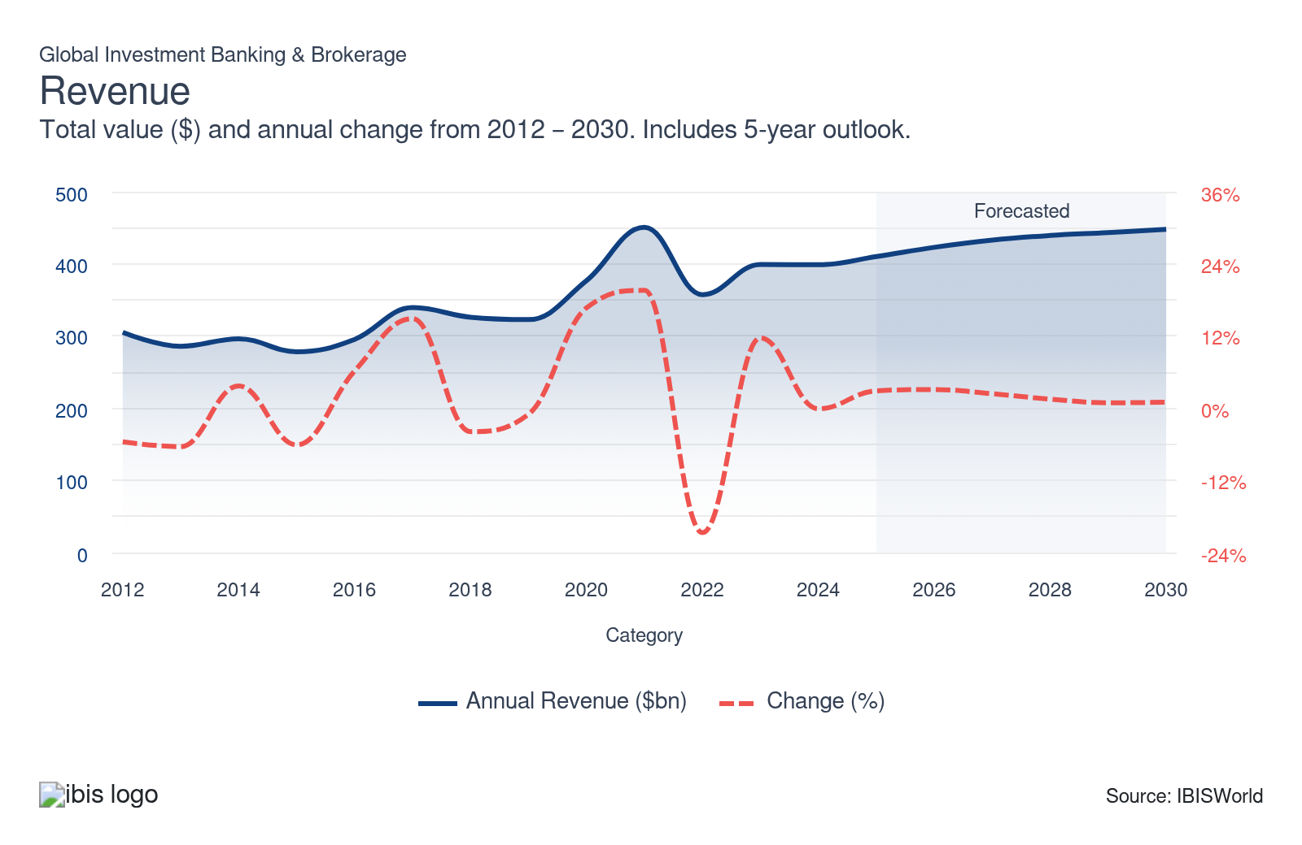
Employees: | ↓ 2020-25 Employees CAGR -0.3%
Employees  230k  ’20-’25 ↓ 0.3 %  ’25-’30 ↑ 1.4 % | Employees per Business  10  ’20-’25 ↑ 2.3 %  ’25-’30 ↑ 0.7 % | Revenue per Employee  $2m  ’20-’25 ↑ 2.1 %  ’25-’30 ↑ 0.4 %
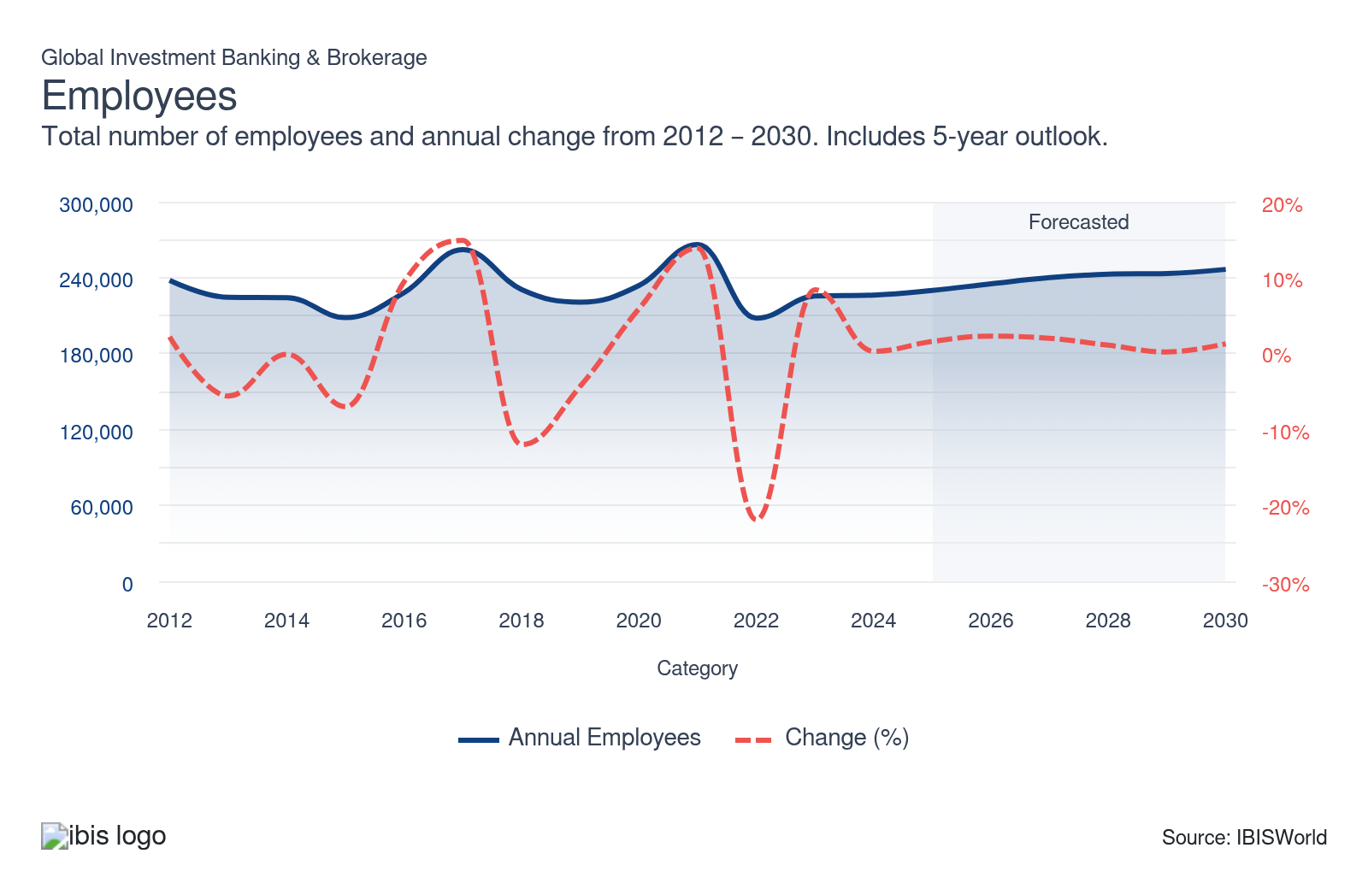
Businesses: | ↓ 2020-25 Business CAGR -2.6%
Businesses  23,274  ’20-’25 ↓ 2.6 %  ’25-’30 ↑ 0.7 % | Employees per Business  10  ’20-’25 ↑ 2.3 %  ’25-’30 ↑ 0.7 % | Revenue per Business  $17.6m  ’20-’25 ↑ 4.4 %  ’25-’30 ↑ 1.1 %
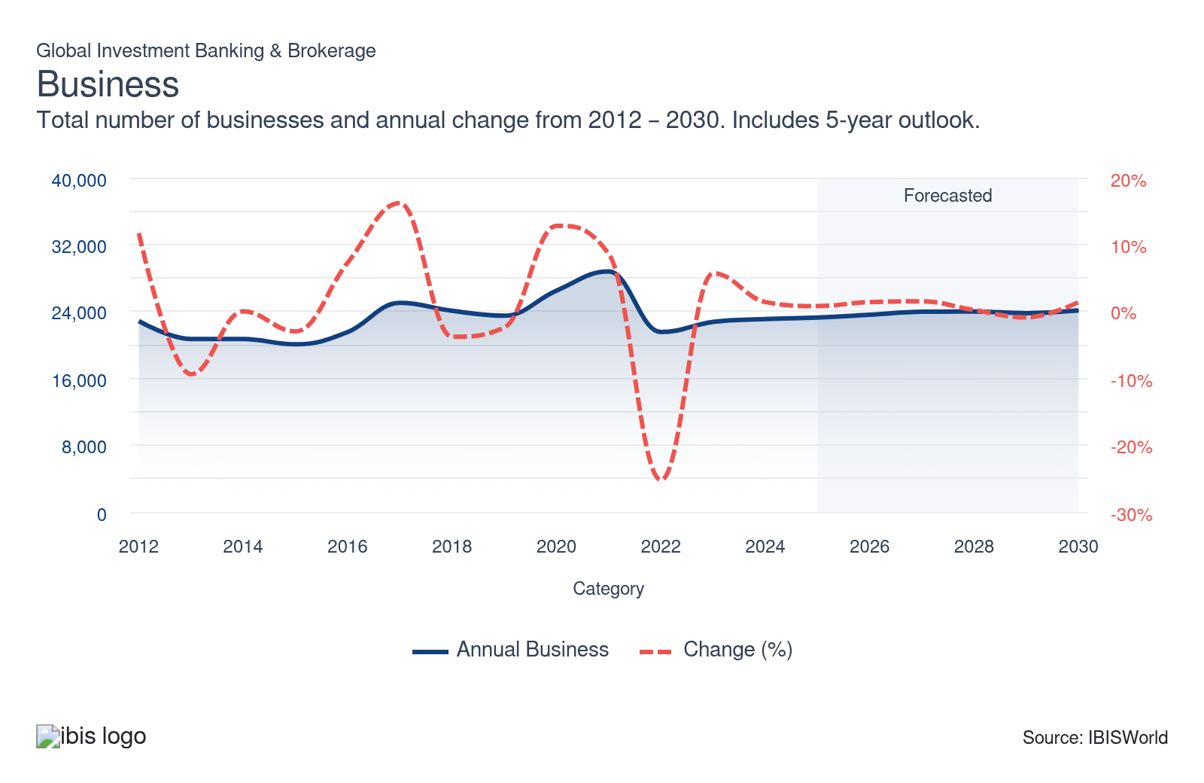
Profit: | ↑ 2020-25 Profit CAGR +4.0%
Total Profit  $142.7bn  ’20-’25 ↑ 4.0 % | Profit Margin  34.8%  ’20-’25 ↑ 3.6 pp | Profit per Business  $6.1m
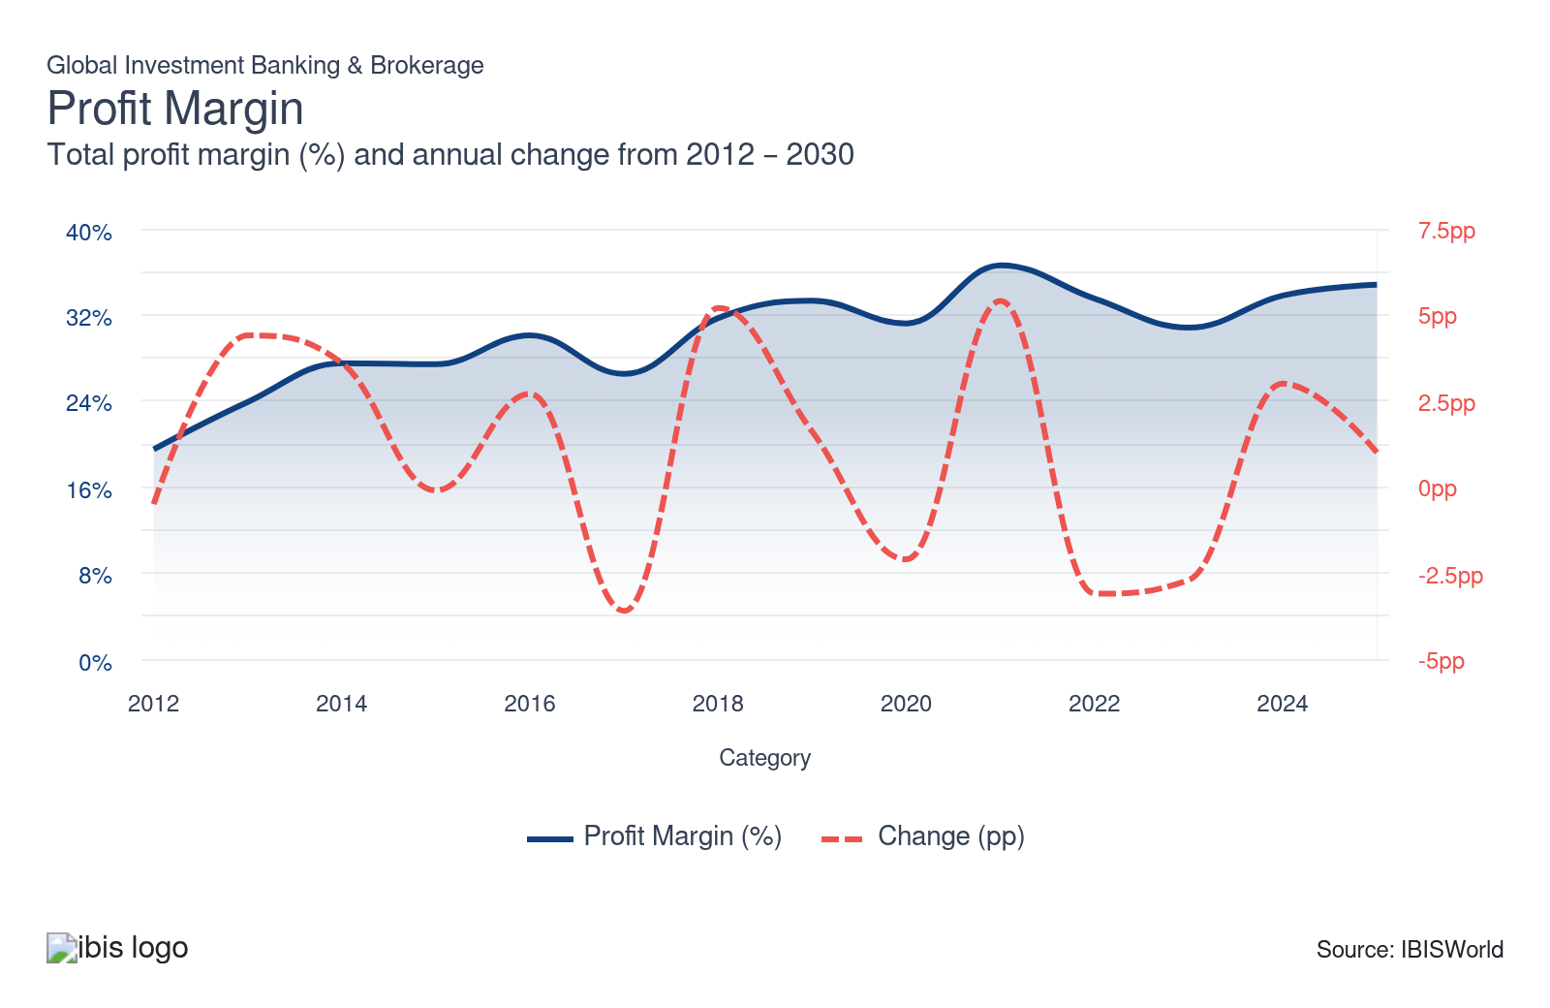
Current Performance
Current Performance

What's driving current industry performance?

AI, data analytics and the retail boom influence industry performance
- The growth of AI tools and technology has enhanced research and trading strategies for investment banks and brokerages. Competitive pressures pushed banks to seek concrete profit and loss impact from AI, while advances in models and infrastructure made deployment feasible. Investment banks and brokerages that couldn't compete were forced to exit the industry, pushing industry establishments down during the period.
- Data has become a strategic asset, with institutions investing in unified data platforms, data pools and programs to capture structured and unstructured sources such as news and transactions. Fragmented data limited cross-selling and risk insight and firms increasingly embedded analytics into banker and trader desktops, therefore insights are consumed in real-time.
- Brokerages are increasingly transitioning to mobile-first platforms, with native apps offering advanced order types, real-time alerts and social trading features. Desktop platforms remain important for sophisticated users but engagement is increasingly mobile-centric. Users globally are more comfortable managing finances from smartphones and mobile capabilities increasingly support higher frequency engagement and reaction to market events.

Volatility in financial markets spurs up revenue
- Trading revenue companies tend to benefit from increased volatility in financial markets, as greater volatility leads to increased trading activity by businesses on the part of their clients as asset prices fluctuate. However, the decline in investor uncertainty during the period limited revenue gains for investment banks and brokerages as trading activity was hindered by reduced uncertainty. In the latter part of the period, the global economy is benefiting from reduced interest rates and easing inflationary pressures. Although in 2025, investor uncertainty jumped significantly, increasing volatility in financial markets and boosting trading activity, pushing industry revenue higher.
- At the onset of the period, companies materially benefited from an increase in investor uncertainty due to economic disruptions in supply chains and the global economy overall, which led to heightened volatility in financial markets. A significant spike in investor uncertainty led to increased demand for investment banks and brokerages, as customers sought to navigate volatile markets through these institutions.
- Also, as a result of increased volatility in financial markets, there was a jump in trading activity. Businesses experienced an increase in demand for trade executions from their clients, contributing to industry revenue growth throughout the period. Trading activity climbed in part due to the significant rise in global investor confidence over the past five years.

The industry grew due to various economic trends
- Underwriting securities is a key activity for investment banks, focusing on debt and equity products. The industry guides clients in issuing stocks and bonds, raising capital efficiently and managing investment risks. By leveraging their expertise, investment banks help clients navigate regulatory hurdles and volatile market conditions.
- Equity underwriting activity and, by extension, the total value of Initial Public Offerings (IPOs), has increased, garnering greater demand for industry services and products. Secondary equity offerings became increasingly popular. Because secondary offerings need to be structured similarly to IPOs, companies help businesses underwrite their secondary offerings. Equity markets grew during the period, for example, the S&P 500 climbed and the growth in global investor confidence, grew demand for industry services.
- Also, the increased popularity of exceptional purpose acquisition companies (SPACs) benefited the industry at the onset of the period. SPAC IPOs surged in 2020 and 2021, with over 200 launched in 2020 and more than 600 in 2021. Because this process requires equity underwriting, the uptick in popularity of SPACs in recent years has increased demand for companies' services.

Smaller businesses evolve to remain in the market as larger players expand
- Many of the industry's smaller businesses benefited from a change in the services they offer to clients. Smaller or boutique investment banks and brokerages are increasingly prioritizing merger and acquisition advisory services. Merger and acquisition advisory services focus more on personal relationships and do not require smaller players to match their larger rivals with scale.
- Acquisition activity has been significant and the most prominent companies continue to control market share. Despite industry growth, the number of establishments declined due to larger companies acquiring smaller ones, which hindered competition. In addition, increased regulation further limited new entrants, consolidating market power among larger dominant players.
- Cost-cutting measures among the industry's major companies are also enabling their ability to expand market share in the industry. While this trend has affected front-office staffing, investment banks have been hiring workers with technology backgrounds to support their evolving business needs. The growth of advanced technologies has resulted in industry employment and wages as a share of revenue declining during the period, boosting industry profit growth.

What influences industry volatility?

Industry revenue follows the financial market cycle
- Volatility primarily depends on any aggregate changes in fees for industry operators and trading gains, which in turn rely on the current macroeconomic climate. Typically when trading volumes climb, global investment banks and brokerages earn increased revenue from fees.
- When economic and financial market conditions are above average, this industry tends to perform well. Alternatively, when financial markets take a turn for the worse, revenue is often hit hard, as trade fees are reduced and investor uncertainty rises.

Changes to regulations can significantly impact on volatility
- New rules and regulations can change the way companies operate and the products and services they offer, leading to fluctuations in demand and market conditions. Regulatory changes often prompt companies to reassess and modify their strategic approaches and adapt operations to remain compliant and competitive with evolving legal and economic environments.
- Government regulations and tax law changes actively influence volatility in global investment banking. These actions can significantly alter market dynamics, affecting risk assessment and financial strategies. Global investment banks rapidly adjust their risk models and capital allocation to manage government regulations and tax laws.

Investment performance is a key factor affecting volatility
- The value of these trades can fluctuate based on a variety of factors, such as market conditions, interest rates and global economic events. Changes in investment performance can affect demand for products and services, leading to industry volatility.
- When interest rates are high, investors shift to bonds and other less risky assets. As interest rates are being slashed globally, investors will increasingly shift to equities and be more willing to take on risk.
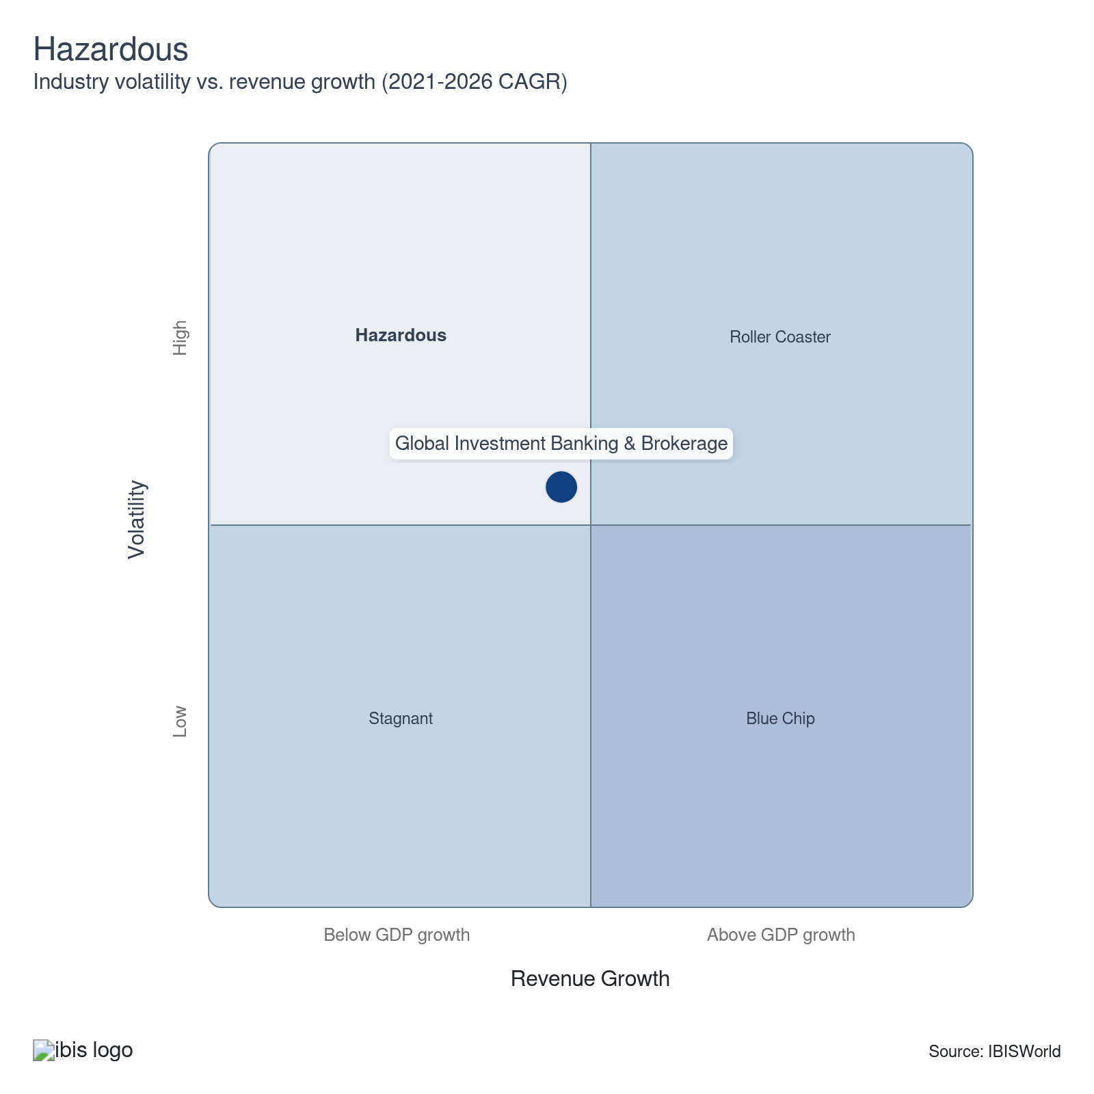

How do successful businesses overcome volatility?
Having a good reputation
A strong brand name and a history of successful transactions boost an operator's profile in the market and the likelihood of generating new clients.
Access to a highly skilled workforce
Industry operators rely heavily on labor for their service offerings. Consequently, maintaining a highly trained workforce is crucial to successfully underwrite equity and debt.
Outlook | ↑ 2025-30 Revenue CAGR +1.8%

What's driving the industry outlook?

High inflation is anticipated to persist and investor uncertainty will climb
- Inflation remains a critical concern, poised to impact global markets further. Even with expected interest rate cuts at the onset of the outlook period, inflation will still play a prominent role. As inflationary pressures are persistent, nations will cautiously monitor economic trends and employment figures before adjusting interest rates. Central banks will seek to drive economic growth, aiming to boost market activities.
- Investor uncertainty is anticipated to rise during the outlook period which may increase trading activities in financial markets and boost overall industry revenue. Increasing investor uncertainty will likely result in more volatility in financial markets, increasing the potential demand for value-added opportunities and returns. Also, during volatile markets, investors will increasingly seek advisory services to navigate uncertain and volatile markets.
- As interest rates are cut early on in the period, this will have several effects on the industry. Declining interest rates will reduce demand for fixed-income securities and less risky assets such as bonds. As rates are slashed worldwide, there will be a greater shift of capital from fixed-income securities into the equity markets, increasing demand for stocks, riskier investments and alternative asset classes.

Improving financial market conditions will support demand
- Improving financial market conditions will support greater corporate activity, increasing demand for equity underwriting. The MSCI World Index, which measures the performance of equity markets of the world's 48 leading economies, excluding the United States is anticipated to climb, which will increase trading activity and be a driver of industry revenue over the next five years. In addition, the S&P 500 is expected to climb, further driving demand for equity assets.
- The overall macroeconomic conditions are set to improve and reduce inflationary pressures over the next five years. As inflationary pressures ease, interest rates will be tamed, which will likely stimulate global economic activity and make it more affordable for individuals to attain loans.
- Businesses will benefit from reduced rates early on in the period, as this will likely enable businesses to attain more affordable loans to finance business expansions and operations. However, as loan volumes is set to increase due to reduced rates, interest income earned on each loan will fall, limiting industry profit growth.

Regulation surges in order to protect retail investors
- The financial industries, including the Securities Brokerage industry, still live in the shadow of the Great Recession. The regulations enacted in its aftermath continue in place all these years later. Financial regulations are strict and will continue to be introduced in order to help protect investors and limit systemic risk. Greater regulations will increase compliance costs for the industry.
- The 2010 Dodd-Frank Act continues to impose restrictions on industry operations. As the retail market continues to expand, the government will actively implement more regulations, aiming to enhance oversight. Although these regulations ensure a stable financial environment, fostering investor confidence and safeguarding the integrity of the global markets.
- The government's response to the retail investor frenzy over meme stocks and cryptocurrency in the current period indicates what will come in the next few years. New regulations are anticipated to be introduced regarding cryptocurrency following the regulations introduced in the latter part of the period. The Property Bill (Digital Assets) will classify digital holdings including cryptocurrency and digital art as personal property in the United Kingdom. An increase in regulations such as this are anticipated in the outlook period.

The scale of AI and boutique firms will redefine the competitive landscape
- AI technology has grown and become a significant tool for the industry during the current period and this trend is expected to continue into the outlook period. AI will continue to transform dealmaking and capital markets by enhancing target screening, valuation scenarios and helping identify investment risks while seeking to maximize investment returns. Dealmaking will climb with global merger and acquisition activity volumes and IPO pipelines set to climb over the next five years.
- Competition from boutique investment banks and brokerages is set to increase moving forward. As a result, industry establishments are set to increase as new entrants seek to satisfy the growing global demand for investment banking and brokerage services. Smaller new entrants will be better able to compete with larger established players due to advanced technological tools such as AI and data analytics tools. This will push larger firms to become even larger, allowing their economies of scale and increased efficiencies to outcompete the offerings of boutique firms.
- Many boutique firms are led by former senior executives from major investment banks and specialize in providing advisory services, particularly in M&A and strategic counsel, without offering trading or underwriting services. Although their service offerings are not as broad as those of larger players, these boutiques often encounter fewer conflicts of interest. With experienced teams and established client relationships, they pose a significant threat to the advisory business of larger banking and brokerage firms.
Life Cycle | Mature

Why is the industry mature?

Contribution to GDP
The industry has grown during the current period and is in the mature phase of its life cycle. Despite the industry being in the mature phase of its life cycle, increased regulatory measures and strong market acceptance of products and services worldwide drive continued contribution to economic expansion.

Market Saturation
The industry is experiencing increasing consolidation as larger and more established investment banks and brokerages strive to strengthen their market position. Companies offer similar products and seek differentiation by price and new technological services. Smaller niche players compete by leveraging specialized expertise and personalized client services.

Innovation
Innovation is limited in the industry. Investment products have yet to see much change since the Great Recession. The most significant innovations are the advances in new technology and the overall digitization of the industry. New technologies like AI and data analytical tools enable investment banks and brokerages to better analyze trends, large data sets and identify patterns.

Consolidation
Consolidation is increasing as the industry's products and services are widely accepted. The need for faster technological networks may push smaller brokerage firms to consolidate in an effort to expand profit and reduce costs. Smaller players compete in the industry by offering niche and personalized products and services.

Technology & Systems
The use of telecommunications services, information technologies and electronic distribution technologies in the industry is increasing rapidly. The industry's technology improves the efficiency and effectiveness of information delivery and services to clients. By embracing new and improved technological systems, the industry can provide clients with faster and more reliable financial solutions.

4. Products and Markets
https://my.ibisworld.com/gl/en/industry/J5521-GL/products-and-markets
Largest Market  $168.6bn  Debt origination | Product Innovation  Moderate

Key Takeaways
- Debt underwriting’s share of industry revenue has increased. Investment banks serve as the middlemen between companies looking to raise funds by securitizing a company’s ownership or debt to be traded to investors in exchange for capital.
- Investment banks and securities dealers provide corporate finance services. However, regulatory and technological changes over the past decade blurred the lines between products offered by businesses and other financial services companies.

Products and Services
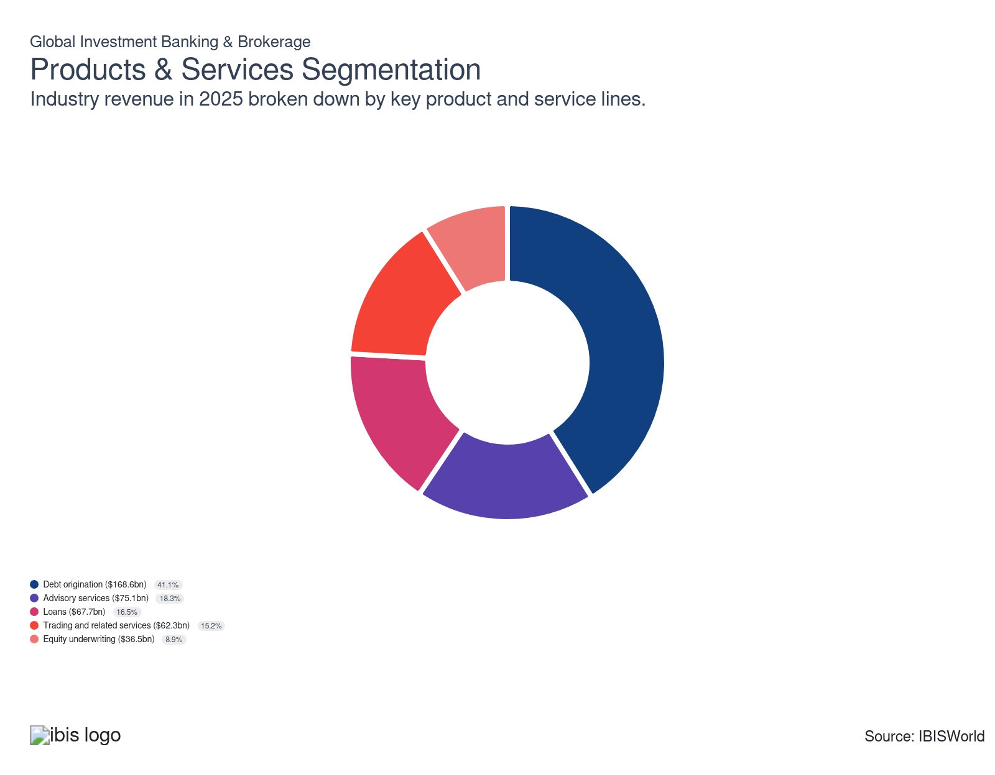

How are the industry’s products and services performing?

Trading and related services jump global investor confidence rises
- Investment banks conduct sales, trading, custodian, financing and market-making activities on securities, futures exchanges and other markets. Investment bankers and brokers engage in trading across every asset class depending upon requests from clients and their own trading desks. Their trading activities can be broken down into principal trading and market-making, proprietary trading and prime brokerage.
- Principal trading by investment banks involves the use of client money to purchase securities, with the expectation of price appreciation, allowing for the subsequent sale of these securities. Trading and related services have benefited from increased volatility in global equity markets. Increased market volatility and declining investor uncertainty led to increased trading volumes as firms sought to mitigate investment risks while also seeking to profit from significant price fluctuations at the same time. The jump in global investor confidence boosted demand for trading activities, causing this segment to account for a larger share of revenue.
- The trading and related services segment remains a significant share of industry revenue in the current year. The growth in electronic trading also contributed to maintaining this segment's significant share of revenue. The increase in electronic trading has enabled greater trading volumes and efficiency in executing trades, allowing investment banks and brokerages to handle an increase in transactions at a reduced cost.

Debt origination rise as interest rates are elevated
- Investment banks offer companies looking to raise capital through debt markets. Investment banks help corporations and governments issue debt instruments like investment-grade and high-yield debt, bank loans and bridge loans. Debt instruments enable companies to raise capital to expand operations while retaining equity in the business. Governments utilize investment banks to issue debt instruments for financing infrastructure projects.
- At the onset of the period, debt underwriting increased as businesses sought to secure financing to stabilize their financial positions because of economic uncertainty. Debt underwriting continued to climb in the latter part of the period despite the high-interest-rate environment. Companies turned to debt markets to finance projects and acquire the necessary capital for mergers and acquisitions.
- Following economic disruptions at the onset of the period, investment-grade debt issuances surged as the most trustworthy borrowers actively pursued financial security. Seeking to enhance liquidity, these trustworthy borrowers tapped into debt markets. By securing higher cash reserves, these borrowers aimed to bolster their balance sheets and strengthen their financial position.

Equity underwriting demand rises as equities climb
- Investment banks assist companies wishing to go public (initial public offerings) by issuing common, preferred and other equity-related securities. There has been an increase in the number of companies going public through initial public offerings (IPOs). The favorable market climate and increased global investor confidence led to a greater appetite among investors for new growth opportunities.
- The surge in secondary equity offerings and SPAC underwriting at the onset of the period significantly boosted demand for equity underwriting services, reflecting increased market activity and investor interest in new financial instruments. SPAC underwriting continued to be strong, specifically in 2021 when there were over 600 SPAC offerings. However, SPAC underwriting declined as interest rates climbed worldwide in the middle of the current period.
- Companies used secondary equity offerings to raise additional business capital. In contrast, SPACs have been used by investment professionals to increase money, list the vehicle publicly on an exchange and then acquire a target company.

Advisory services climb as investor uncertainty falls
- Financial advisory services encompass a wide range of strategic assignments designed to enhance corporate value and operational efficiency. These services include strategic advisory assignments related to mergers and acquisitions (M&A), divestitures, corporate defense activities, risk management, restructurings, spin-offs, exchange offers and shareholder relations.
- Major investment banks provide advisory services on dividend policy, valuations, foreign exchange exposure and financial risk management. The fiscal stimulus at the onset of the period contributed to rising asset prices and advisory services, which led to rising fees. The trend of rising asset prices and increasing complexities in financial markets has led to higher fees associated with advisory services.
- Financial planning and wealth management services include investment advisory and management. This segment has increased in popularity recently as retail investors seek to minimize risk in a volatile investment climate. However, the decline in investor uncertainty limited the number of retail investors seeking to minimize investment risk.

Loans are limited due to the elevated interest rate environment
- Investment banks primarily offer business loans through dedicated client relationship teams and various product partners. Investment banks collaborate with clients to understand their financial needs, providing tailored lending solutions. By leveraging specialized expertise and a broad range of products, investment banks ensure their clients and businesses receive the financial support necessary to achieve their strategic objectives.
- Product offerings encompass commercial and corporate bank loans and commitment facilities, tailored to meet the needs of diverse clients. The industry serves banking clients, middle market commercial clients and large multinational corporations, providing flexible financial solutions.
- As interest rates remain elevated globally, demand for loan products will likely dip as loans become increasingly more expensive. However, as inflationary pressures ease worldwide and countries continue slashing interest rates in the latter part of the period, the demand for loan products will climb as they become more affordable.

What are innovations in industry products and services?

New tools like data analytics and artificial intelligence are innovating the industry
- Companies are investing in digital tools that offer more convenient and accessible ways for users to manage their accounts. Companies embraced tech tools like data analytics and artificial intelligence to enhance their operations and boost efficiency.
- Global investment banks and brokerages are looking to attain the latest technology which helps with operations and efficiency. Having the newest technology can reduce the need for human capital and help banks and brokerages identify trends, improve investment strategies and minimize investment risk.

What products or services do successful businesses offer?
Provision of a related range of services
The provision of an array of services, including trading, financial advisory and underwriting services, enables investment banks to maximize potential fees.
Secure access to well-established brand names
Partnering with or utilizing recognized brands increases market visibility and client confidence, critical for expanding client bases and achieving success in investment banking and brokerage services.

Major Markets
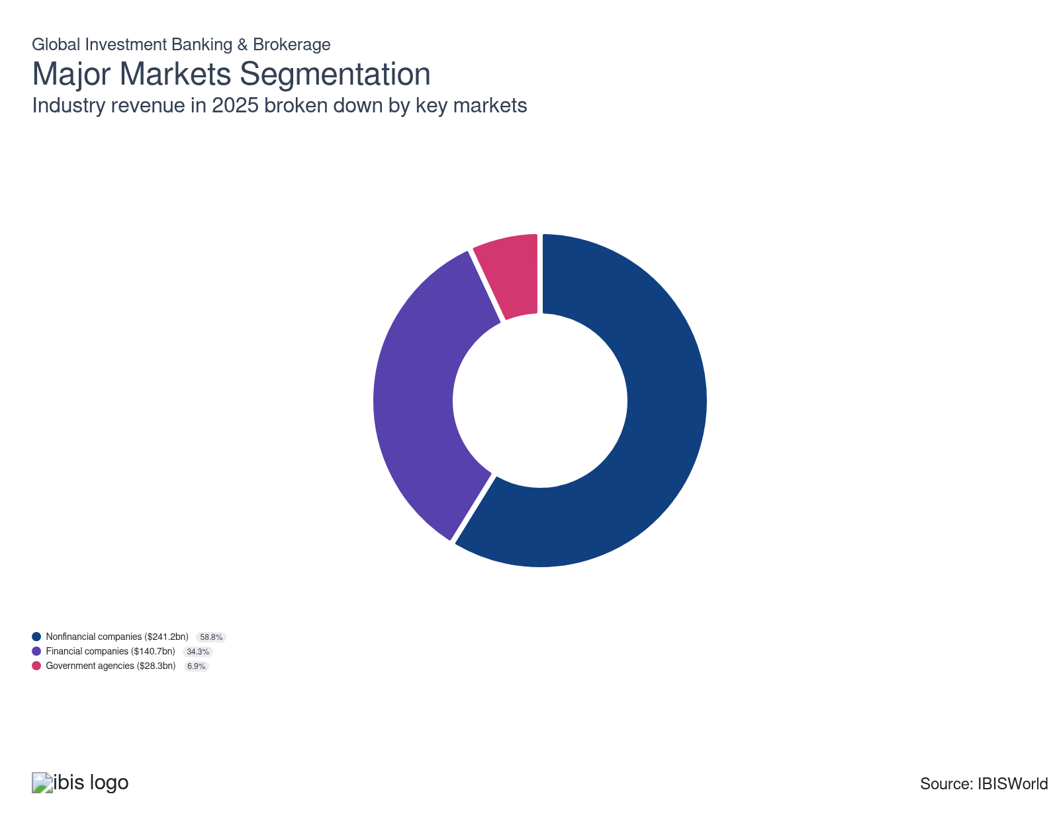

What’s influencing demand from the industry’s markets?

Financial companies comprise a significant share of revenue
- This segment includes banks, insurance companies, brokerages and financial advisors. Financial firms primarily use investment banks for a variety of trading and related services, including underwriting and securities sales to manage risk and raise capital, execute client trading orders and provide related financing, research, financial advisory and wealth management services.
- Major investment banks also provide trading services, such as market-making, clearing, settlement and custody services to financial firms to facilitate their larger-scale trading needs. Due to volatility in financial markets, investment banks encountered significant trading activity in order to meet the trading needs of customers. As a result, trading fees climbed along with trading activity boosting this market.
- This segment is the second-largest market in the industry and is estimated to account for over one-third of industry revenue in the current year. As investor uncertainty declines and market volatility stabilizes in the latter part of the period amid global interest rate cuts and easing inflationary pressures, this market will encounter a growing share of revenue.

The corporations market rises due to the climbing equity markets
- Corporate operators, defined as nonfinancial businesses, account for the majority of revenue for industry operators where the downstream markets include energy and power, industrials and technology. Growth in downstream markets contributes to growth in the corporation's market.
- Investment banks and securities dealers assist corporations with underwriting and selling equity and debt securities in financial markets to raise capital. Investment banks also act in a broker-dealer capacity and assist corporate firms with hedging risks and trading securities for a profit.
- Nonfinancial businesses are estimated to account for over one-half of revenue in the current year. The growth in US equity markets and the MSCI world index, which measures the performance of equity markets of the world's 48 leading economies excluding the US also grew. Increases in equity markets contributed to growth in underwriting and selling equities to raise capital, driving this market's growth.

International Trade

Some industries don't directly import or export goods. See reports at the manufacturing level for international trade data on relevant products.

5. Geographic Breakdown
https://my.ibisworld.com/gl/en/industry/J5521-GL/geographic-breakdown

Key Takeaways
- Brokerages are in proximity to large population regions. The size of the population affects the size of the retail market.
- Europe’s share of business locations has declined. Asset values have dipped as a result of consumer and business confidence falling along with their wealth, as many entities have moved assets elsewhere to more stable economies in other regions.

Business Locations

Where are industry businesses located?

North America is the center of the global financial world
- The United States is a global financial hub and conducts most of the region's investment banking activities.
- North America, the United States in particular, has become less dominant in terms of its share of global banking activity.
- Being a relatively mature market, it was able to weather the economic volatility experienced throughout the period.

Europe's share of business locations has declined
- Many European banks never fully recovered from the global financial crisis. In addition, in early 2022, Russia declared war on Ukraine. The continuing conflict has severely disrupted the global economy.
- Asset values have dipped as a result of consumer and business confidence falling along with their wealth, as many entities have moved assets elsewhere to more stable economies in other regions. However, as interest rates are slashed in the latter part of the period worldwide, investment into equities and other asset classes will rise, boosting demand for industry services.
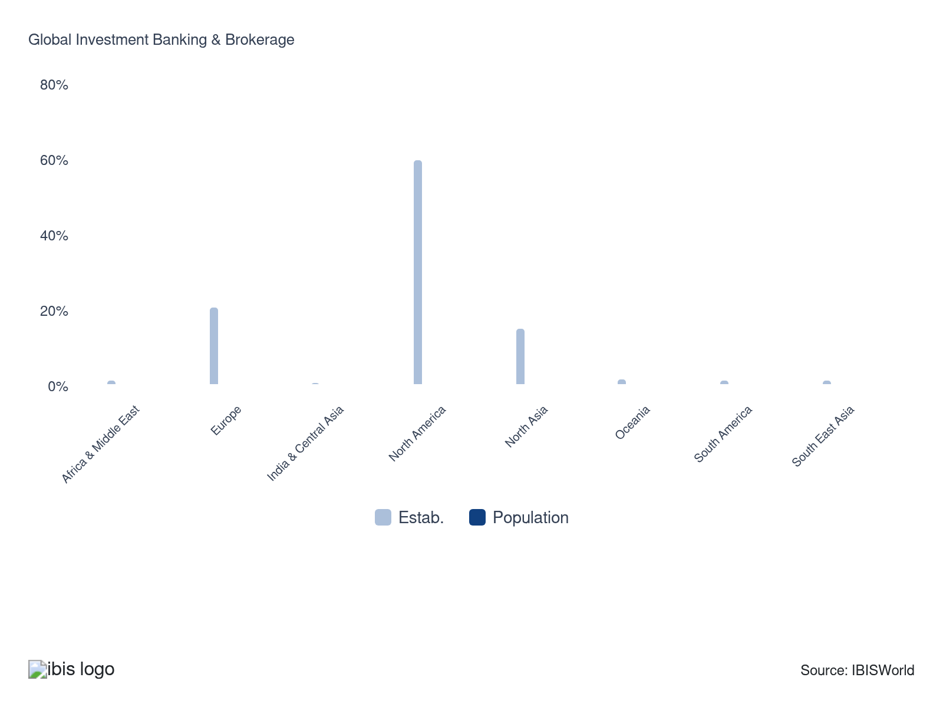

6. Competitive Forces
https://my.ibisworld.com/gl/en/industry/J5521-GL/competitive-forces

Key Takeaways
- Economies of scale are essential. Businesses with the best and most cost-effective technological network are more competitive.
- Zero commission fees on trading push companies to create better user experiences. The securities broker with the prettiest, most intuitive and most helpful user interface wins.

Concentration
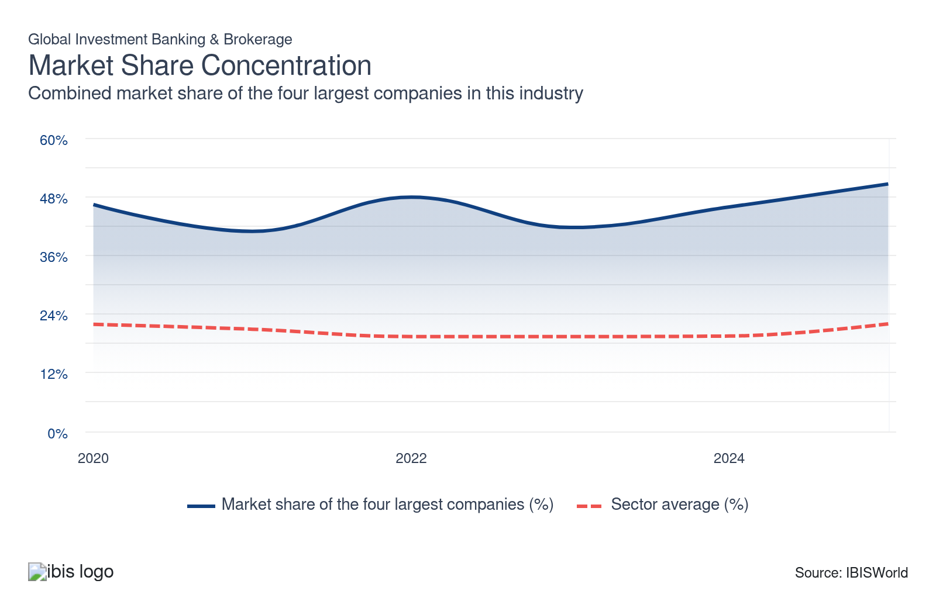

What impacts the industry’s market share concentration?

Larger firms benefit from economies of scale, reducing costs and boosting efficiency
- Operators that can expand their operations can achieve economies of scale faster, create lower costs and expand operations more efficiently. Larger firms leverage advanced technological infrastructure such as networks to achieve economies of scale. Enhanced analytic tools enable firms to process large data volumes and more efficiently identify investment opportunities.
- Brokers that can't achieve economies of scale may benefit from merging with larger operators, which would increase the industry's market share concentration. However, advancements in technological tools and applications have enabled smaller players to compete more effectively, enabling them to streamline operations and enhance their competitiveness.

Changes in the overall macroeconomic landscape affect market share concentration
- The level of interest rates and economic growth affect the amount of capital available for investment. As interest rates climb, there is typically a decrease in capital available for investment in equities. Although rates were cut in the latter part of the period, capital available for investment in equities increased.
- Economic downturns and uncertainty can lead to increased market share concentration among larger players as weaker firms are forced to exit the market. During the period, industry establishments declined as the volatile macroeconomic landscape forced smaller players out of the industry.

How do successful businesses handle concentration?
Provision of a related range of services
The provision of an array of services, including trading, financial advisory and underwriting services, enables investment banks to maximize potential fees.
Having a good reputation
A strong brand name and a history of successful transactions boost an operator's profile in the market and the likelihood of generating new clients.

Barriers to Entry
High | Increasing

What challenges do potential industry entrants face?

Legal
- The industry faces stringent regulations, requiring companies to adhere to rigorous legal standards and maintain high capital reserves, directly increasing their operating costs. These requirements pressure firms to allocate more resources to compliance infrastructure and oversight, which can elevate the cost of doing business.

Start-Up Costs
- Establishing a new firm requires significant upfront investments in technology, capital, skilled personnel and other resources. New entrants often struggle to compete with established firms, which benefit from economies of scale, extensive client networks and strong reputation. These high start-up costs can discourage new entrants.

Differentiation
- New entrants must differentiate themselves from established competitors to gain a foothold in the market. With longstanding firms already holding strong client relationships, attracting customers becomes difficult. The need for differentiation, combined with customer loyalty to established brands, raises barriers.

Labor Expenses
- Newly established firms must hire experienced professionals, such as analysts and advisers, whose expertise is essential for providing reliable investment services and research. These skilled employees are critical for a firm's reputation and competitiveness, driving up initial operating expenses for industry companies.

How can potential entrants overcome barriers to entry?
Well-developed internal processes
Since the global financial crisis, industry operators have increased their focus on consolidating trading platforms as a means to combat the effect of regulation on profit.
Develop strong technical product knowledge
Mastering the technical details of financial products allows firms to innovate and tailor solutions to client needs, distinguishing themselves in a competitive market.

Substitutes
Low | Steady

What are substitutes for industry services?

Private Equity
- Investors in private equity firms pool their funds to make investments in privately held businesses. Private equity firms focus on creating value through operational improvements and strategic management, eventually seeking profitable exits via sales or IPOs.
- Private equity firms, in contrast to investment banks, typically take a more hands-on approach to managing their investments, frequently accepting board seats and collaborating closely with portfolio companies to support their expansion.

Venture capital firms
- Venture capital firms make investments in start-ups with significant potential for expansion. They might help these businesses succeed by funding, mentoring, and providing support.
- Investment should be visible as a subset of private value, with an emphasis on more modest, more creative organizations.

How do successful businesses compete with substitutes?
Access to a highly skilled workforce
Industry operators rely heavily on labor for their service offerings. Consequently, maintaining a highly trained workforce is crucial to successfully underwrite equity and debt.

Buyer & Supplier Power
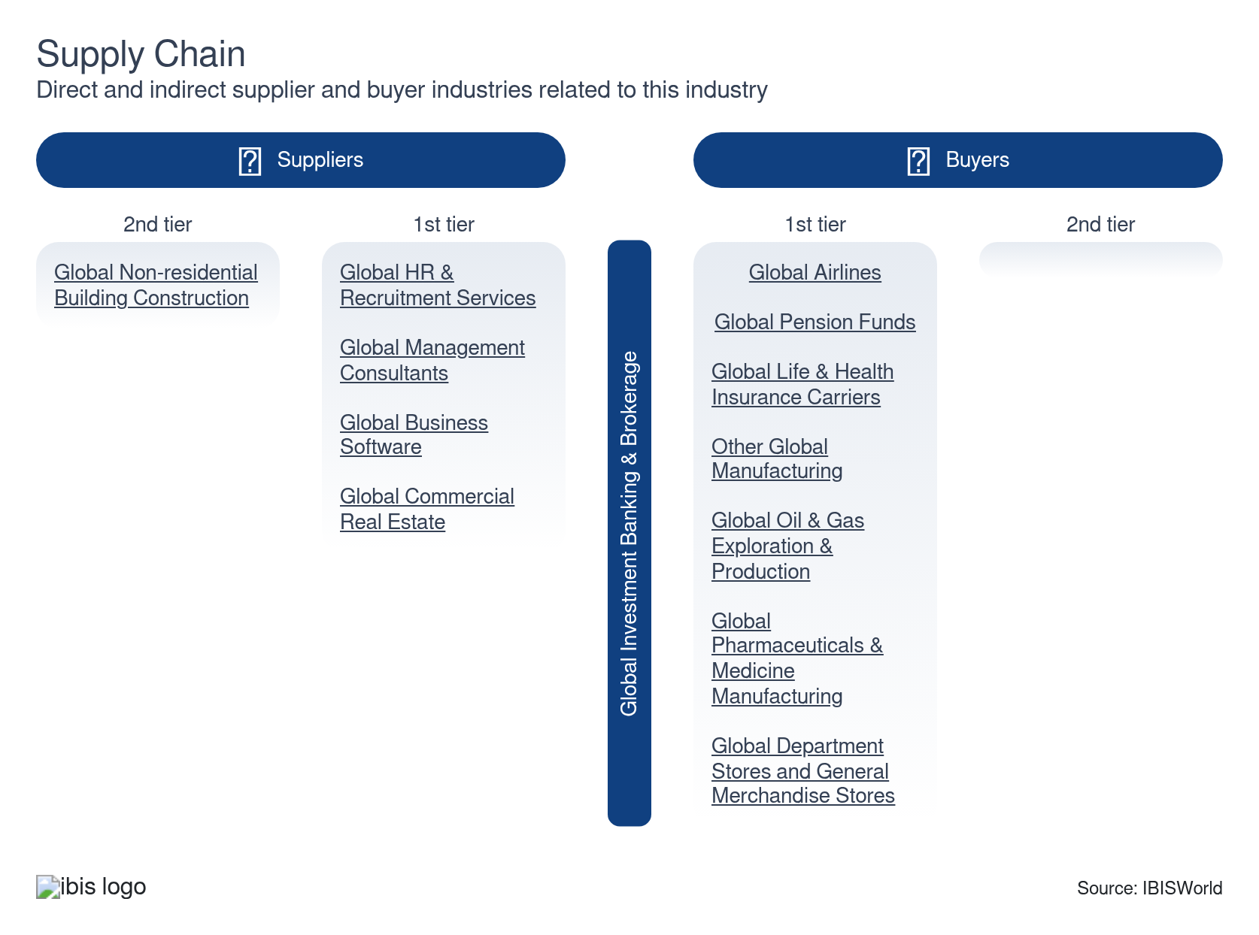

What power do buyers and suppliers have over the industry?

Buyers: Increasing competition
Moderate | Increasing
- In the investment banking and brokerage industry, there is more competition than ever before due to the rise of alternative finance and fintech businesses. Choosing investment banks with whom to work may give buyers more options and more power.
- Buyers will inherently become increasingly picky when choosing an investment firm, forcing bankers and brokers to create more niche products.

Suppliers: Energy costs and government regulation
High | Increasing
- The regulations set by different governments affect how businesses operate. More regulations can increase operating costs for industry players which may hinder industry profitability.
- Regulatory changes can pose a significant challenge, incurring unexpected costs. In addition, investment services require fast and reliable technological networks, so price fluctuations can prove costly.

How do successful businesses manage buyer & supplier power?
Provision of a related range of services
The provision of an array of services, including trading, financial advisory and underwriting services, enables investment banks to maximize potential fees.
Ability to effectively communicate and negotiate
The ability to effectively communicate information is key to financial advisory services, and for negotiation in merger and acquisition, as well as initial public offering activities.

7. Companies
https://my.ibisworld.com/gl/en/industry/J5521-GL/companies

Key Takeaways
- Major companies have adapted to high interest rates and less liquidity. However, interest rate cuts recently increased liquidity but inflationary pressures still persist.
- Environmental, social and governance (ESG) is becoming more important to companies. Companies are either selecting to trade investment products based on ESG factors or creating a more inclusive and diverse working environment.

Market Share
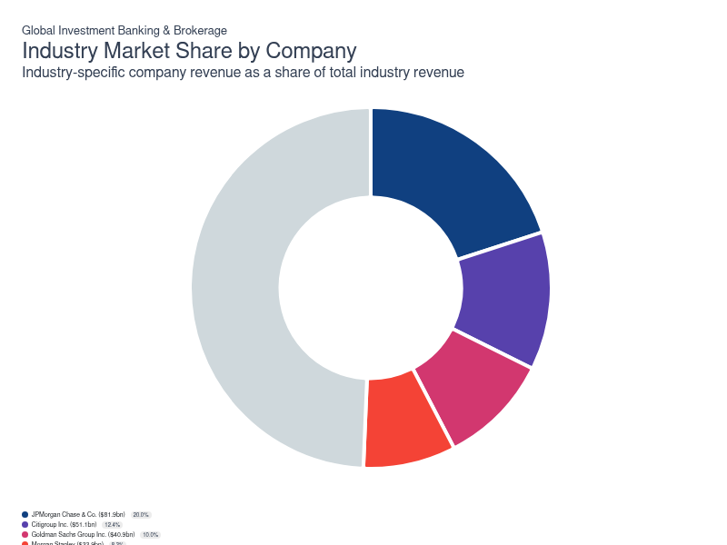
Chart displays current year only in the PDF version of this report. You can view and download chart for all other years associated with this industry on my.ibisworld.com.

Companies
Company | Market Share (%)  2025 | Revenue ($m)  2025 | Profit ($m)  2025 | Profit Margin (%)  2025
JPMorgan Chase & Co. | 20.0 | 81,911.6 | 30,128.7 | 36.8
Citigroup Inc. | 12.4 | 51,054.0 | 15,509.3 | 30.4
Goldman Sachs Group Inc. | 10.0 | 40,855.7 | 17,764.1 | 43.5
Morgan Stanley | 8.3 | 33,929.9 | 11,891.9 | 35.0
Bank of America Corporation | 6.8 | 27,934.9 | 10,040.9 | 35.9
Deutsche Bank AG | 4.7 | 19,103.9 | 6,351.3 | 33.2

JPMorgan Chase & Co.
JPMorgan Chase & Co.
Company Details
Company Details
Industry Specific Revenue (2025) | $81.9bn
Industry Profit (2025) | $30.1bn
Company Employees (2025) | 290,000
Market Share (2025) | 20.0%

Description
Description
JPMorgan Chase & Co. (JP Morgan Chase) is the largest financial holding company in the United States by assets. They were founded in 1799 and are headquartered in New York City. The company holds leading positions in the provision of investment banking, commercial banking and asset management for personal, corporate, institutional and government clients.

Brands and Trading Names
Brands and Trading Names
- JP Morgan Chase & Co.
- Chase Insurance Agency
- JP Morgan Securities LLC

Other Industries
Other Industries
- GLGlobal Commercial Banks

Company’s Industry Revenue, Market Share, and Profit Margin Over Time
Company’s Industry Revenue, Market Share, and Profit Margin Over Time
Year | Industry Revenue ($ million) | Market Share (%) | Profit Margin (%)
2020 | 49284 | 15.9 | 34.7
2021 | 51943 | 13.4 | 40.6
2022 | 59635 | 18.1 | 32.1
2023 | 64353 | 16.9 | 31.5
2024 | 70114 | 18.0 | 35.4
2025 | 81912 | 20.0 | 36.8

What's impacting JPMorgan Chase & Co.'s performance?

Acquisitions fuel growth
- In January 2023, the company announced its acquisition of China International Fund Management Company. This acquisition will help the company expand its global assets, thus encouraging growth.
- In 2022, the company acquired Renovite Technologies inc, a leading cloud-native payments technology company.

J.P. Morgan wins Institutional Investor's Global Research award
- J.P. Morgan was awarded number one in all of institutional investor's Global Research team awards.
- This is the second time J.P. Morgan won the top spot in all three awards.
Citigroup Inc.
Citigroup Inc.
Company Details
Company Details
Industry Specific Revenue (2025) | $51.1bn
Industry Profit (2025) | $15.5bn
Company Employees (2025) | 229,000
Market Share (2025) | 12.4%

Description
Description
Citigroup Inc. (Citigroup) holds leading positions in the provision of consumer banking and credit, corporate and investment banking, securities brokerage, transaction and wealth management services. Headquartered in the United States, Citigroup employs an estimated 240,000 full-time employees as of December 2022.

Brands and Trading Names
Brands and Trading Names
- Citigroup Inc

Company’s Industry Revenue, Market Share, and Profit Margin Over Time
Company’s Industry Revenue, Market Share, and Profit Margin Over Time
Year | Industry Revenue ($ million) | Market Share (%) | Profit Margin (%)
2020 | 45088 | 14.6 | 24.5
2021 | 39705 | 10.3 | 36.6
2022 | 41176 | 12.5 | 27.3
2023 | 41475 | 10.9 | 20.8
2024 | 45686 | 11.7 | 28.7
2025 | 51054 | 12.4 | 30.4

What's impacting Citigroup Inc.'s performance?

Technological advances drive growth
- Citigroup launched a new digital client platform, CitiDirect, for its commercial banking clients. Also, with the growing presence of digital assets, Citi is developing digital asset solutions using blockchain technology. These technologies enhance Citi's products and services regarding digital money, securities and custody.
- CitiDirect will help bring the company's global products and services into a single online platform. Citi has invested in a payments innovation toolkit to create a streamlined and efficient payment processing system.

Citigroup expands through global investments
- Citi has introduced a novel environmentally-friendly time deposit solution in India, crafted to aid institutional customers in optimizing surplus funds while bolstering their commitment to sustainability.
- Citi has strategically invested in Rextie, the foremost fintech in Peru, offering foreign exchange services. This investment marks a historic milestone, as Rextie becomes the first FX fintech in Latin America to secure funding from one of the globe's largest banks.
Goldman Sachs Group Inc.
Goldman Sachs Group Inc.
Company Details
Company Details
Industry Specific Revenue (2025) | $40.9bn
Industry Profit (2025) | $17.8bn
Company Employees (2025) | 46,400
Market Share (2025) | 10.0%

Description
Description
The Goldman Sachs Group Inc. (Goldman Sachs), in addition to holding a leading global position in the provision of investment banking services, also provides securities and investment management services to corporations, financial institutions, government agencies and high-net-worth individuals. Founded in 1869 and headquartered in the United States, the company employs 48,500 individuals across offices located in more than 35 countries, with an estimated 48.0% headcount based outside the Americas.

Other Industries
Other Industries
- Fund Management Activities in Ireland

Company’s Industry Revenue, Market Share, and Profit Margin Over Time
Company’s Industry Revenue, Market Share, and Profit Margin Over Time
Year | Industry Revenue ($ million) | Market Share (%) | Profit Margin (%)
2020 | 21157 | 6.8 | 38.2
2021 | 36734 | 9.5 | 47.3
2022 | 32487 | 9.9 | 43.6
2023 | 29996 | 7.9 | 38.5
2024 | 34943 | 9.0 | 42.7
2025 | 40856 | 10.0 | 43.5

What's impacting Goldman Sachs Group Inc.'s performance?

Technological advances drive growth
- The company has created an in-house application enabling bankers to run real-time customized analyses of different debt structures in client meetings.
- Goldman Sachs also has machine learning and artificial capabilities to analyze factors in SEC filings.

Segment reorganization
- In December 2022 the company reorganized into three segments, Global Banking & Markets, Asset & Wealth Management and Platform Solutions.
- The company has also been focusing on customer-oriented deposit-taking and lending activities. This has been accelerated through its acquisition of GreenSky Inc, which expands its point-of-sale financing.
Morgan Stanley
Morgan Stanley
Company Details
Company Details
Industry Specific Revenue (2025) | $33.9bn
Industry Profit (2025) | $11.9bn
Company Employees (2025) | 80,000
Market Share (2025) | 8.3%

Description
Description
Morgan Stanley holds leading market positions in the provision of a range of financial services. Headquartered in the United States, Morgan Stanley also maintains principal offices in London, Tokyo and Hong Kong. Employing 82,000 workers, the company provides products and services to corporations, government agencies, financial institutions and individuals.

Company’s Industry Revenue, Market Share, and Profit Margin Over Time
Company’s Industry Revenue, Market Share, and Profit Margin Over Time
Year | Industry Revenue ($ million) | Market Share (%) | Profit Margin (%)
2020 | 26476 | 8.6 | 34.6
2021 | 29833 | 7.7 | 39.6
2022 | 24393 | 7.4 | 27.5
2023 | 23060 | 6.1 | 19.4
2024 | 28080 | 7.2 | 31.2
2025 | 33930 | 8.3 | 35.0

What's impacting Morgan Stanley's performance?

Morgan Stanley Acquires RowCal
- RowCal is a provider of homeowners association property management services.
- Morgan Stanley's Capital Partners have acquired the company to grow and expand the services it offers organically.

Morgan Stanley expands artificial intelligence tools
- Morgan Stanley is expanding the use of OpenAI-powered AI tools to the company's investment banking and trading division. The tool enables users attain answers from across the universe of Morgan Stanley's research including on equities, bonds, commodities, industry trends and regions. Users can get a better understanding and search for trends that can improve investment decisions and better understanding financial trends.
- Employees internally have used the new AI tools three times as much as the previous AI tools in 2017. These AI tools are most in demand among salespeople and other client-facing staff who typically take questions from hedge funds or other institutional investors.
Bank of America Corporation
Bank of America Corporation
Company Details
Company Details
Industry Specific Revenue (2025) | $27.9bn
Industry Profit (2025) | $10.0bn
Company Employees (2025) | 212,000
Market Share (2025) | 6.8%

Description
Description
Founded in 1930 and headquartered in Charlotte, NC, Bank of America Corporation (Bank of America) is the second-largest financial holding company in the United States, with respect to assets. The company, serves a broad range of downstream markets with banking, investing and asset management products and services.

Brands and Trading Names
Brands and Trading Names
- Bank of America Merrill Lynch

Other Industries
Other Industries
- GLGlobal Commercial Banks

Company’s Industry Revenue, Market Share, and Profit Margin Over Time
Company’s Industry Revenue, Market Share, and Profit Margin Over Time
Year | Industry Revenue ($ million) | Market Share (%) | Profit Margin (%)
2020 | 22682 | 7.3 | 37.8
2021 | 24239 | 6.3 | 32.0
2022 | 21064 | 6.4 | 31.4
2023 | 22303 | 5.9 | 33.0
2024 | 25233 | 6.5 | 36.3
2025 | 27935 | 6.8 | 35.9

What's impacting Bank of America Corporation's performance?

Technological advances drive growth
- BAC has invested heavily in technology. While much of the investment is done on the retail banking side, the company has focused on using artificial intelligence for trading and reporting trade data.
- Cybersecurity risk has also propelled an increase in technological investments.

J.D. Power certifies BofA for Outstanding Client Satisfaction
- BAC has been certified two years in a row for outstanding client satisfaction with customer financial health support among banks and credit card issues.
- Holly O'Neill, the President of Retail Banking, said the company was pleased to receive the certification once again.

You can view and download company details on my.ibisworld.com.

8. External Environment
https://my.ibisworld.com/gl/en/industry/J5521-GL/external-environment

Key Takeaways
- Regulation is still heavily influenced by both the Great Depression and Great Recession. The government wants to ensure financial crises don’t occur.
- Revenue volatility in the industry is largely affected by general economic conditions. Industry revenue is mainly generated by interest income and capital gains.

External Drivers

What demographic and macroeconomic factors impact the industry?
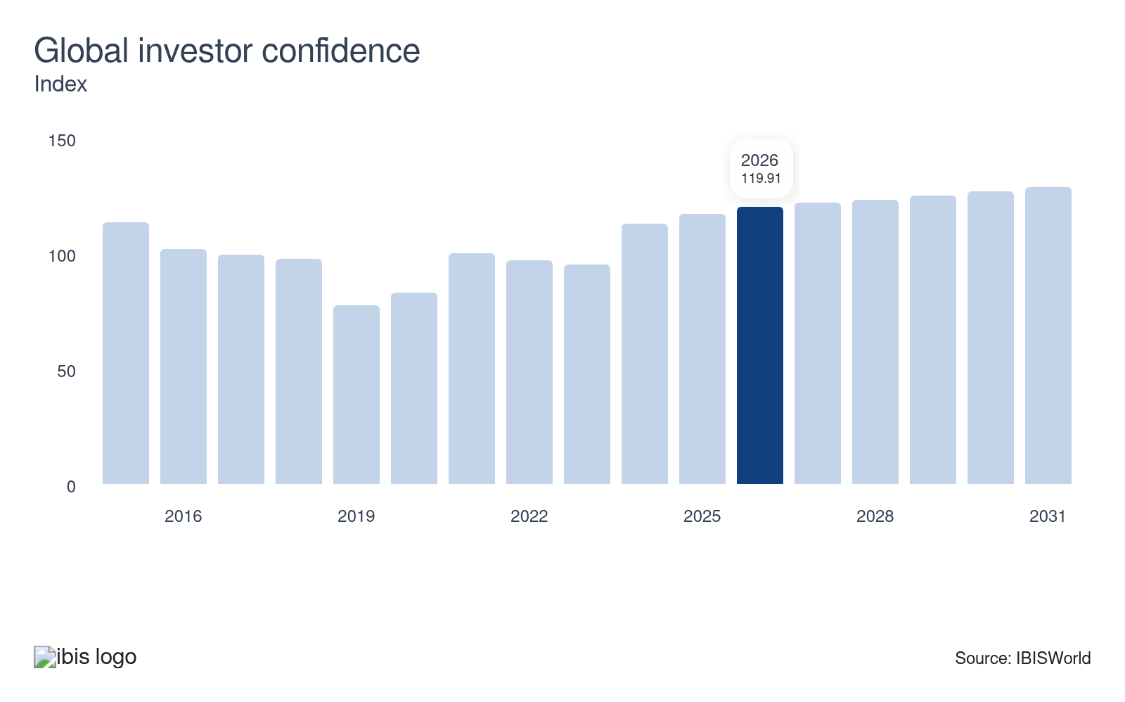
The global investor confidence index measures the attitude of investors, with respect to risk, by analyzing the buying and selling patterns of institutional investors. In general, an increasing penchant for risk among institutional investors benefits the industry's trading service fees dramatically. Moreover, mounting investor confidence is positively correlated with the industry's traditional services as well, particularly equity underwriting. Growth in global investor confidence drives demand for trading activity and supports demand for industry services.
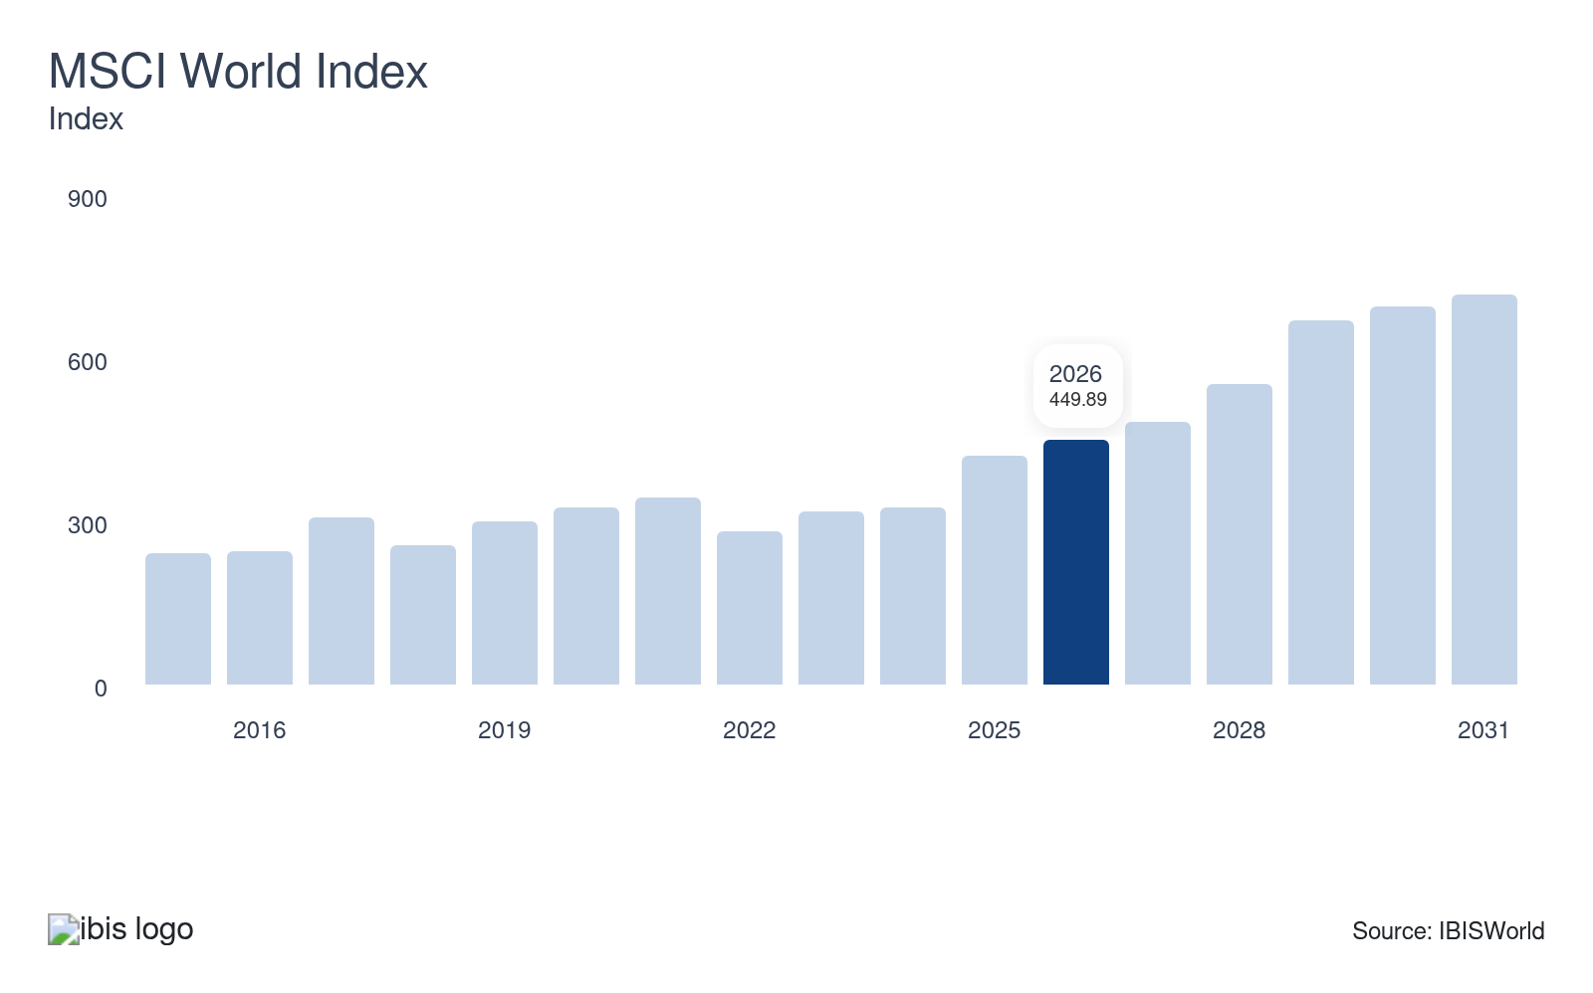
The MSCI World Index tracks the performance of leading global equity markets and is highly correlated with the industry's underwriting and advisory service offerings. Companies are generally more willing to issue additional securities when the prices garnered from these shares are high. As a result, climbing equity market values increase both industry demand and fees. Growth in the MSCI World Index generates greater demand for the industry and supports industry growth, representing a potential opportunity for the industry.
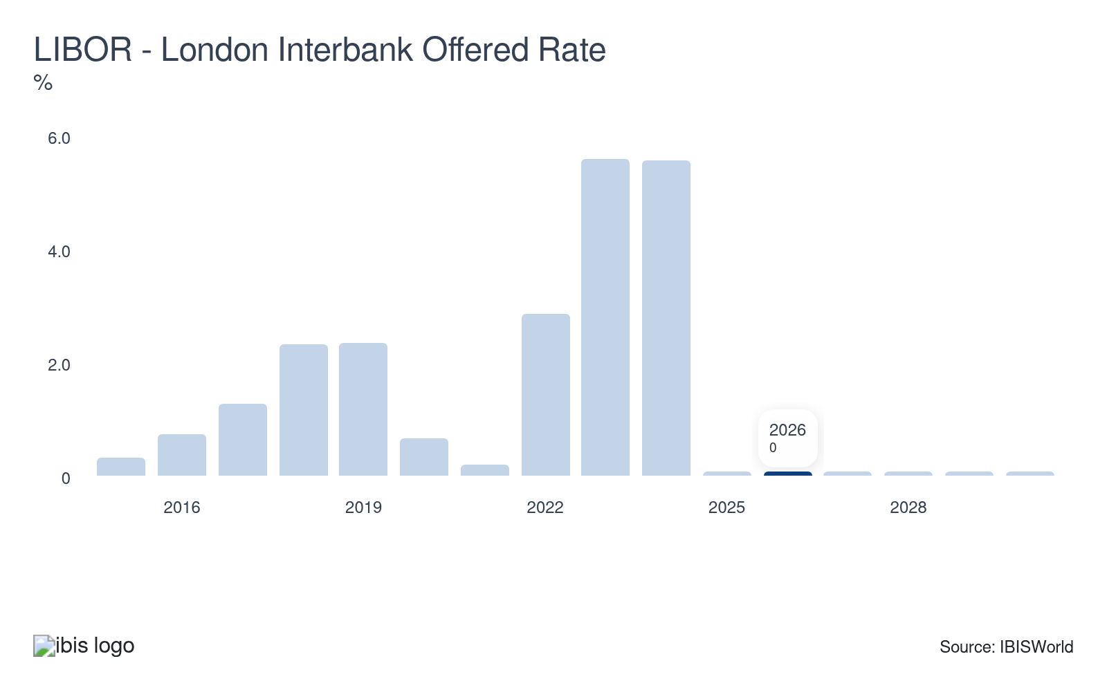
The London Interbank Offered Rate (LIBOR) is the primary benchmark for short-term interest rates across the world. When interest rates increase, debt becomes more expensive for companies and has the potential to discourage debt origination demand. Declines in the LIBOR is due to the response to mounting inflation caused by rising costs as the supply chain continues to be disrupted. Despite rate cuts, elevated interest rates pose a potential threat to the industry.
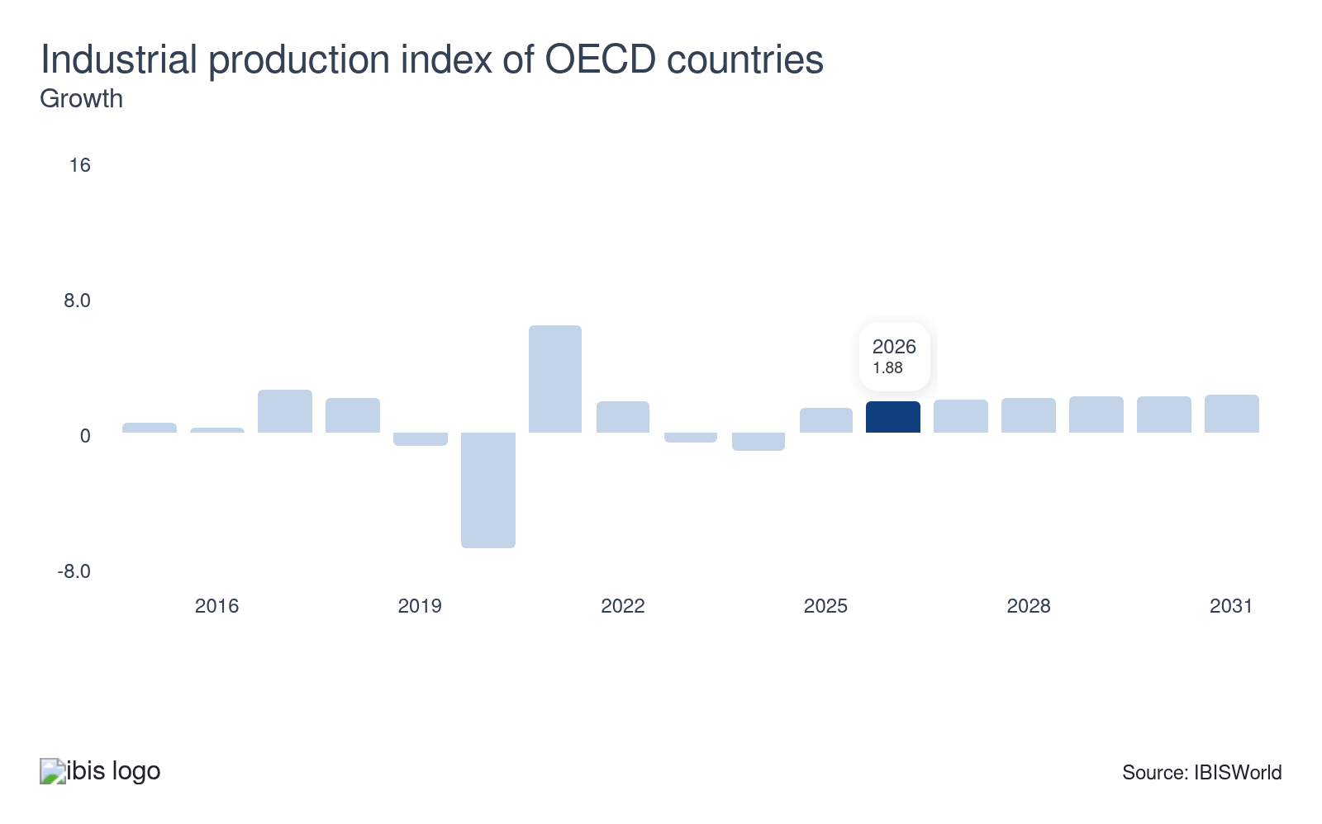
The industrial production index of OECD countries measures the production output of industrials of 34 countries across the world. The growth of manufacturing output foments economic activity and investment, which, in turn, generates demand for the industry's services. Growth in the industrial production index of OECD countries will support manufacturing growth and economic activity and investment in manufacturing globally.

Regulation & Policy

What regulations impact the industry?

Dodd-Frank Wall Street Reform and the Consumer Protection Act
The 2010 Dodd-Frank Act, prompted by the subprime mortgage crisis, aimed to enhance financial accountability, transparency and reduce systemic risks. A notable component, the Volcker Rule, approved in 2013, restricts banks with insured deposits from proprietary trading and limits their private equity and hedge fund investments to 3% of the fund's value and bank's core capital. In 2020, regulators eased these restrictions, allowing specific fund investments.

Basel III
Basel III was developed as a response to financial regulation deficiencies uncovered by the global financial crisis. Basel III represents the latest global agreement on bank capital and liquidity requirements agreed upon by the members of the Basel Committee on Banking Supervision. In April 2013, the deadline for Basel III was extended. After a one-year postponement to enhance the operational capabilities of both banks and supervisors in addressing the challenges posed by the pandemic, these changes will be implemented starting from January 1st, 2023 and will be introduced gradually over a span of five years.

MiFID II
The EU's Markets in Financial Instruments Directive (MiFID), enacted after the 2008 crisis, sought to enhance financial market transparency and standardize regulatory disclosures. MiFID II, effective January 3, 2018, further limited trading activities, requiring banks to sell investment research independently, not tied to commissions. Due to the pandemic, February 2022 amendments allowed bundled payments for research on issuers under $1.2 billion, aiding small and mid-cap companies' visibility and liquidity.

Assistance

What assistance is available to this industry?

National Investment Banking Association
Founded in 1982, the National Investment Banking Association (NIBA) is a nonprofit industry association that connects investment banks, brokerages, investment advisors and other financial service providers. NIBA primarily assists the industry by hosting conferences for small- and micro-cap companies. The conferences provide exposure to these companies that seek to network and raise funds. As a result of NIBA efforts, thousands of deals worth over $12.0 billion have been completed.

The Global Financial Markets Association (GFMA)
The Global Financial Markets Association (GFMA) serves as a unified voice for the world’s leading participants in financial and capital markets. Its primary role is to advocate on behalf of these institutions, representing their common interests in the face of global regulatory, market and economic challenges. Its purpose is to unite these participants in addressing issues that uphold the strength of the global capital markets. It provides a platform for dialogue, policy development and best practices that support efficient, well-functioning markets.

Association for Financial Markets in Europe (AFME)
As the representative entity for Europe's wholesale financial markets, the Association for Financial Markets in Europe (AFME) offers extensive knowledge concerning a wide spectrum of regulatory and capital markets matters. It stands as the spokesperson for major global and European banks, as well as other significant participants in the capital market arena. The association actively engages with policymakers, regulators and industry leaders to promote a stable and competitive financial environment that supports sustainable economic progress across Europe’s integrated capital markets.

Asia Securities Industry & Financial Markets Association (ASIFMA)
ASIFMA (Asia Securities Industry & Financial Markets Association) is a self-governing, regional business group consisting of a varied spectrum of more than 165 prominent financial establishments from both the purchasing and selling perspectives. This encompasses banks, asset management firms, expert service enterprises and providers of market infrastructure services.

Securities Industry and Financial Markets Association (SIFMA)
SIFMA stands as the representative entity for the securities sector of the country, uniting the collective concerns of numerous broker-dealers, investment banks and asset managers. Through active advocacy and industry collaboration, the association works to advance policies that foster economic growth, protect investors and enhance market integrity. By uniting market participants and engaging with regulators and policymakers, SIFMA ensures that the financial system remains resilient and competitive to support innovation and long-term prosperity.

9. Financial Benchmarks
https://my.ibisworld.com/gl/en/industry/J5521-GL/financial-benchmarks
Profit Margin  34.8 %  ↑ Higher than sector | Average Wage  $456k  ↑ Higher than sector | Largest Cost  Wages  25.6% of Revenue

Key Takeaways
- Bankers and brokers are compensated well. Wages are high because of the service-based nature of operations and the necessity for highly educated employees.
- Profit doesn't fluctuate significantly between years. Moderate concentration and investment income shield brokers from profit volatility.

Cost Structure
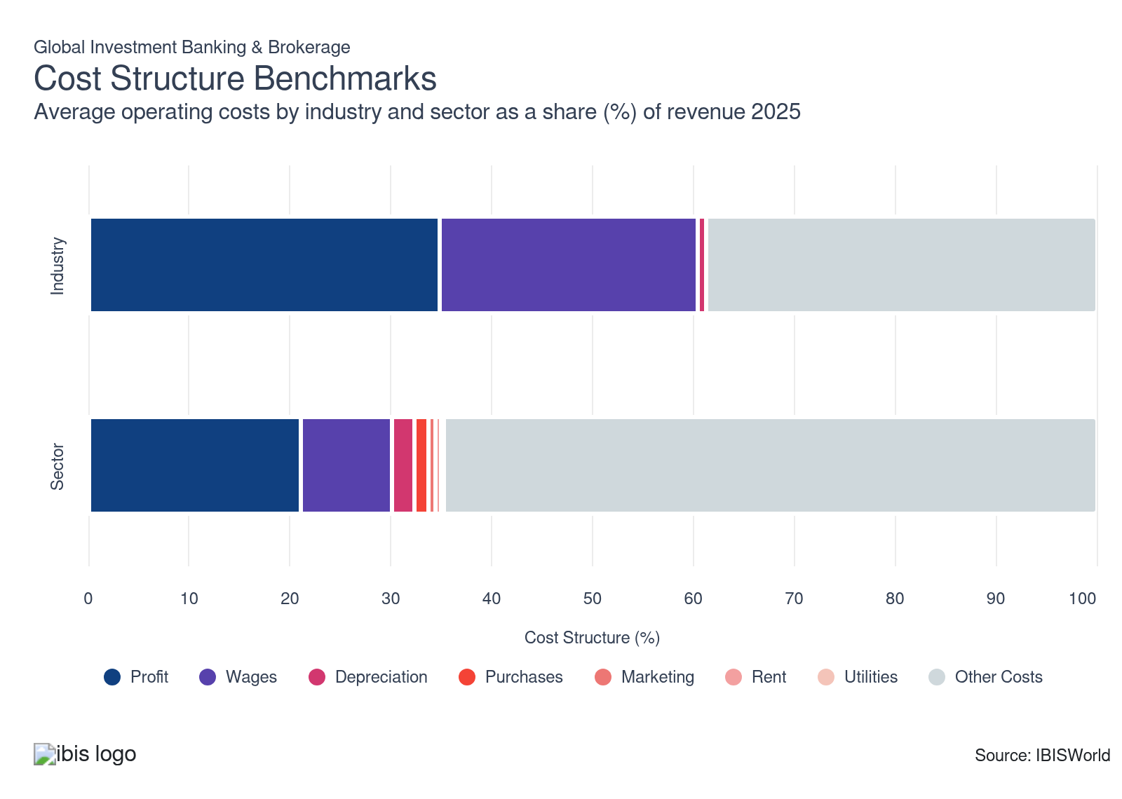
Chart displays current year only in the PDF version of this report. You can view and download chart for all other years associated with this industry on my.ibisworld.com.

What trends impact industry costs?

Investment in new technologies and systems reduces labor costs
- Wage expenses as a share of revenue fell, but are still anticipated to comprise over one-quarter revenue in the current year. General wage declines as a share of revenue result from companies investing in new technologies and systems, reducing labor requirements. These new technologies and systems enabled the industry to increasingly automate repetitive tasks such as data entry, trade execution and compliance checks. Also, the increased use of AI in this sector enables more efficient decision-making and risk assessment, leading to the reduced need for human intervention.
- Still, businesses will continue to need to employ highly educated and skilled workers who command high wages. The reliance on highly educated and skilled workers remains essential despite technological advancements. Employees are critical for tasks requiring complex problem-solving, strategic decision-making and nuanced client interactions.
- High-caliber employees such as financial analysts, investment bankers and compliance specialists command significant wages because of their specialized knowledge. As technology continues to advance, the demand for skilled employees capable of leveraging these tools for maximum efficiency will also rise. Employees will be crucial for interpreting data analytics and maintaining a competitive edge over competitors.
- Companies will continue to invest in technology, leading wage growth to lag behind revenue growth. Firms are increasingly prioritizing investments in technology to enhance efficiency, streamline operations and gain a competitive advantage. Although technology enables cost reduction and operational scalability, wages as a share of revenue will lag as wage growth will not keep pace with revenue growth.

Purchase costs are minimal but important
- Purchase costs are expected to comprise a minimal share of industry revenue in the current year but have increased. Purchase expenses are critical to completing day-to-day tasks. Purchase costs primarily consist of technology acquisition, including software licenses, data analytics platforms and IT infrastructure. These purchases are crucial for maintaining a competitive edge.
- Purchase costs increased among businesses because of increased demand for analytical tools and updated technologies. Analytical tools and advanced technologies, such as artificial technologies, enable firms to operate more efficiently. As these technological purchases continue to be crucial for firms in the industry, this will contribute to greater purchase costs to sustain operations and foster industry growth.

Profit lags despite falling wages and increased investments in technology
- Profit lagged but still comprises over one-quarter of industry revenue in the current year. Despite the increased use of technology and reduced wages as a share of revenue, industry profit fell in the current period. However, increased volatility in the equities market and interest rates have limited profit declines.
- The equities market encountered significant volatility throughout the current period due to various headwinds. Throughout the period, countries globally increased interest rates to tackle rising inflation, which also contributed to volatility in financial markets. The industry benefited from increased market volatility as there was greater demand for trading services due to increased scalability. As market volatility persists in the current year, firms will continue to encounter strong demand for trading services.
- Increasing demand for advisory services and the volatile interest rate environment enabled investment banks and brokerages to weather market volatility and limit profit declines. Investor uncertainty declined, limiting demand for industry services. As investor uncertainty declines, the industry will experience limited trading opportunities and limited transaction volumes.

Other costs are a significant expenses
- Investment banks and brokerages have significant miscellaneous costs in the form of insurance, hedging, legal and administration. Miscellaneous costs increased over the past five years and comprise over one-quarter of industry revenue in the current year.
- Costs related to regulatory compliance continue to mount for investment banks, given legislation introduced as a result of the global financial crisis. These regulations require firms to implement comprehensive risk management systems, adhere to stricter reporting standards and ensure client protection measures. Firms invest heavily in compliance infrastructure, which aims to meet evolving regulatory requirements and minimize risk, which significantly impacts operational budgets.

Depreciation costs are minimal and reflect the gradual wear and tear on physical assets
- Depreciation costs are minimal and relatively steady. Depreciation costs typically arise from tangible assets, including technology infrastructure, trading platforms and office equipment. These costs reflect the gradual wear and tear on crucial physical assets needed for day-to-day operations.
- Effectively managing depreciation expenses enables companies in the industry to allocate resources towards technology upgrades and maintain a competitive edge in the fast-paced financial sector. Depreciation costs are also driven by the need for advanced and up-to-date systems that experience higher depreciation costs compared to older technology.

Rent expenses are minimal but climb slightly
- Rent costs generally stem from leasing prime office spaces in major financial centers. For example, investment banks may pay more for premium office spaces in or near major cities worldwide such as New York or London, securing proximity to clients and market infrastructure.
- Managing rent expenses effectively allows firms to balance operational efficiency and cost control, ensuring they maintain a visible and accessible presence for existing clients and prospective clients. Rent expenses comprise a small share of revenue and climbed slightly during the period.

Utility costs are limited but necessary
- Utilities costs in the industry primarily cover electricity, water, heating, cooling and telecommunications for high-usage office environments and data centers. A significant portion of utility costs go toward powering advanced trading floors, server rooms and high-speed internet connections essential for real-time market data and transactions.
- Despite utility costs accounting for a minimal share of revenue and remaining relatively steady, these costs are critical because a minor downtime during operations can cause substantial financial losses. Firms have invested in energy-efficient technologies to ensure operational continuity.

Marketing costs climb and are minimal
- Marketing costs comprise a minimal share of revenue and grew slightly over the past five years. Marketing costs primarily include expenditure on client acquisition and relationship management. Investment banks invest in high-profile events and industry conferences to attract clients.
- Significant resources also go into digital marketing and maintaining a robust online presence. Given the relationship-driven nature of this industry, a major portion of marketing costs is relationship-focused and generally tailored toward building trust with sophisticated clients.
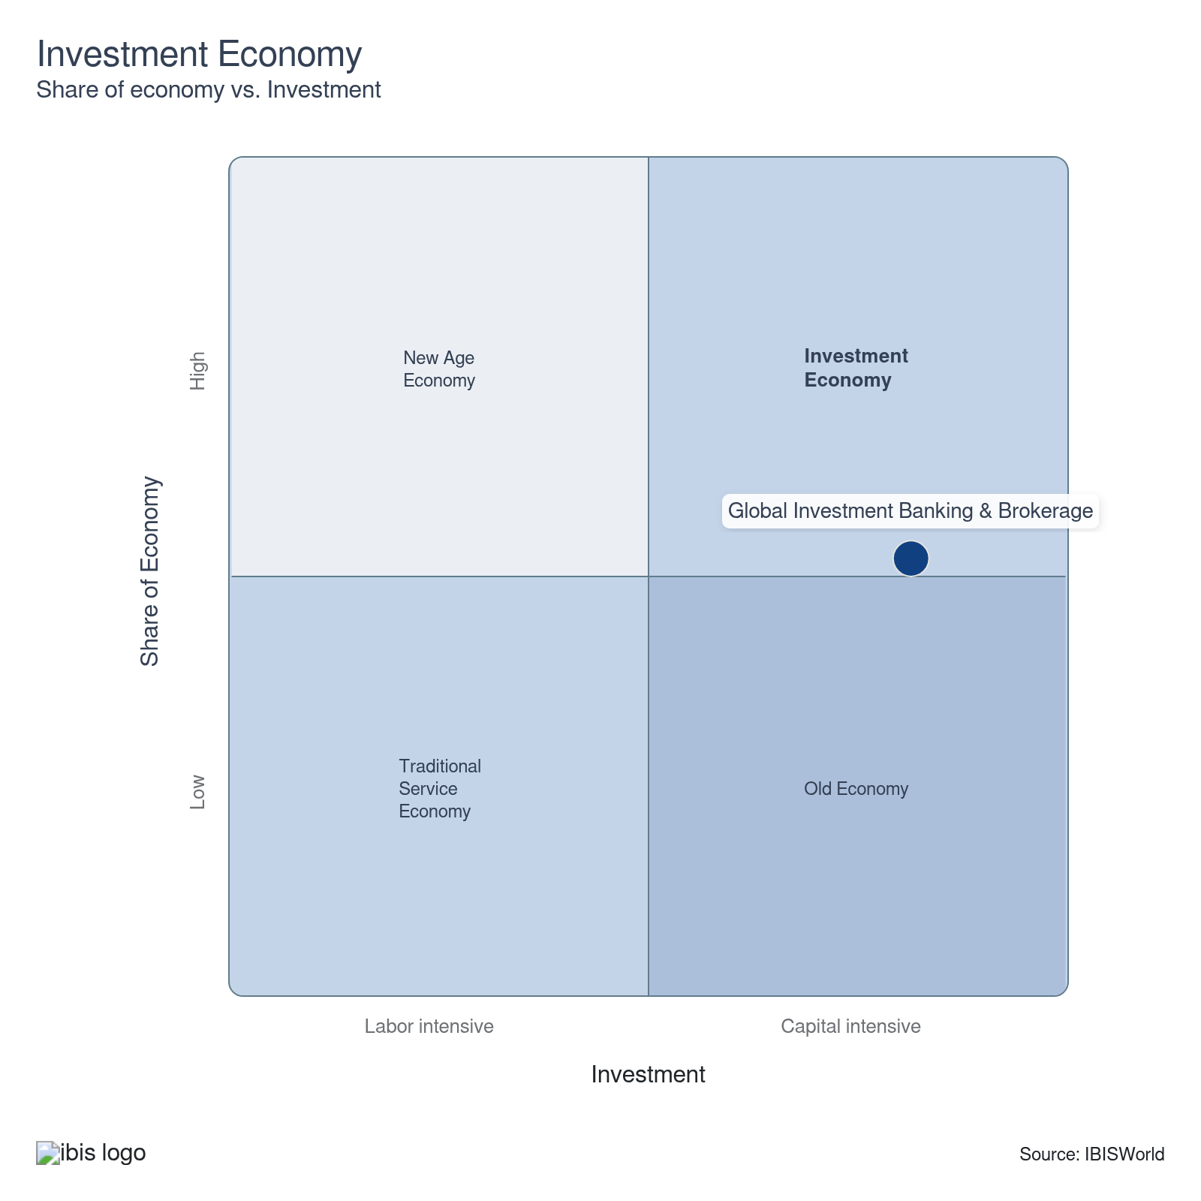

Key Ratios
Year | Revenue per Employee  ($) | Revenue per Enterprise  ($ Million) | Employees per Estab.  (Units) | Employees per Enterprise  (Units) | Average Wage  ($) | Wages/ Revenue  (%) | Estab. per Enterprise  (Units) | IVA/ Revenue  (%)
2005 | 1,535,319 | 19.6 | 10.7 | 12.8 | 377,278 | 24.6 | 1.2 | 47.9
2006 | 1,644,526 | 23.3 | 10.4 | 14.2 | 357,483 | 21.7 | 1.4 | 53.3
2007 | 1,272,155 | 21.6 | 11.0 | 17.0 | 360,938 | 28.4 | 1.5 | 62.4
2008 | 1,532,932 | 21.3 | 12.1 | 13.9 | 481,138 | 31.4 | 1.2 | 63.3
2009 | 1,637,477 | 19.5 | 9.8 | 11.9 | 346,692 | 21.2 | 1.2 | 46.9
2010 | 1,552,299 | 17.7 | 9.4 | 11.4 | 425,632 | 27.4 | 1.2 | 45.2
2011 | 1,389,034 | 15.8 | 9.3 | 11.4 | 448,923 | 32.3 | 1.2 | 53.3
2012 | 1,283,355 | 13.4 | 9.5 | 10.4 | 444,153 | 34.6 | 1.1 | 55.0
2013 | 1,273,477 | 13.8 | 9.4 | 10.8 | 402,899 | 31.6 | 1.2 | 56.4
2014 | 1,321,625 | 14.3 | 9.2 | 10.8 | 453,244 | 34.3 | 1.2 | 62.3
2015 | 1,335,104 | 13.9 | 9.3 | 10.4 | 432,935 | 32.4 | 1.1 | 60.8
2016 | 1,294,214 | 13.7 | 9.6 | 10.6 | 404,116 | 31.2 | 1.1 | 62.1
2017 | 1,294,679 | 13.6 | 9.2 | 10.5 | 437,091 | 33.8 | 1.1 | 61.7
2018 | 1,413,641 | 13.5 | 8.4 | 9.6 | 437,941 | 31.0 | 1.1 | 63.3
2019 | 1,462,900 | 13.7 | 8.3 | 9.4 | 438,893 | 30.0 | 1.1 | 64.2
2020 | 1,611,948 | 14.2 | 7.8 | 8.8 | 460,612 | 28.6 | 1.1 | 60.6
2021 | 1,692,307 | 15.7 | 8.1 | 9.3 | 463,149 | 27.4 | 1.1 | 64.8
2022 | 1,719,002 | 16.6 | 8.4 | 9.7 | 453,037 | 26.4 | 1.1 | 60.8
2023 | 1,771,129 | 17.5 | 8.6 | 9.9 | 455,765 | 25.7 | 1.2 | 57.4
2024 | 1,762,791 | 17.3 | 8.5 | 9.8 | 455,338 | 25.8 | 1.2 | 60.5
2025 | 1,784,103 | 17.6 | 8.6 | 9.9 | 456,447 | 25.6 | 1.2 | 61.3
2026 | 1,798,578 | 17.9 | 8.6 | 10.0 | 457,188 | 25.4 | 1.2 | 61.4
2027 | 1,804,296 | 18.1 | 8.7 | 10.0 | 457,478 | 25.4 | 1.2 | 61.4
2028 | 1,810,482 | 18.3 | 8.7 | 10.1 | 457,793 | 25.3 | 1.2 | 61.4
2029 | 1,822,970 | 18.6 | 8.8 | 10.2 | 458,423 | 25.1 | 1.2 | 61.5
2030 | 1,817,045 | 18.6 | 8.8 | 10.2 | 458,125 | 25.2 | 1.2 | 61.4
2031 | 1,819,902 | 18.7 | 8.8 | 10.3 | 458,269 | 25.2 | 1.2 | 61.5
*Figures are inflation adjusted to 2026
*Figures are inflation adjusted to 2026

10. Key Statistics
https://my.ibisworld.com/gl/en/industry/J5521-GL/key-statistics

Industry Data

Values
Year | Revenue  ($ Million) | IVA  ($ Million) | Estab.  (Units) | Enterprises  (Units) | Employment  (Units) | Wages  ($ Million)
2005 | 468,740.6 | 224,561.2 | 28,599 | 23,881 | 305,305 | 115,184.7
2006 | 568,290.7 | 302,637.3 | 33,370 | 24,377 | 345,565 | 123,533.6
2007 | 512,302.0 | 319,677.7 | 36,676 | 23,681 | 402,704 | 145,351.2
2008 | 464,467.6 | 293,973.1 | 25,138 | 21,813 | 302,993 | 145,781.5
2009 | 420,418.9 | 197,090.1 | 26,243 | 21,557 | 256,748 | 89,012.6
2010 | 364,897.4 | 164,870.8 | 25,100 | 20,577 | 235,069 | 100,052.9
2011 | 323,400.6 | 172,386.5 | 25,073 | 20,451 | 232,824 | 104,520.0
2012 | 305,224.3 | 167,814.9 | 25,096 | 22,851 | 237,833 | 105,634.3
2013 | 285,783.5 | 161,131.9 | 23,961 | 20,693 | 224,412 | 90,415.3
2014 | 296,264.8 | 184,595.2 | 24,253 | 20,688 | 224,167 | 101,602.4
2015 | 278,249.0 | 169,285.9 | 22,479 | 20,061 | 208,410 | 90,227.9
2016 | 295,370.6 | 183,372.8 | 23,722 | 21,524 | 228,224 | 92,228.9
2017 | 339,376.8 | 209,423.5 | 28,609 | 25,019 | 262,132 | 114,575.6
2018 | 326,021.1 | 206,508.1 | 27,391 | 24,072 | 230,625 | 101,000.3
2019 | 322,810.9 | 207,131.1 | 26,569 | 23,483 | 220,665 | 96,848.3
2020 | 376,831.4 | 228,365.7 | 30,045 | 26,486 | 233,774 | 107,679.2
2021 | 450,603.8 | 292,151.2 | 32,852 | 28,773 | 266,266 | 123,320.9
2022 | 357,423.6 | 217,279.6 | 24,718 | 21,530 | 207,925 | 94,197.7
2023 | 399,258.5 | 229,005.2 | 26,226 | 22,754 | 225,426 | 102,741.2
2024 | 398,752.2 | 241,344.7 | 26,598 | 23,083 | 226,205 | 102,999.8
2025 | 410,165.3 | 251,395.4 | 26,854 | 23,274 | 229,900 | 104,937.2
2026 | 422,962.7 | 259,514.8 | 27,262 | 23,598 | 235,165 | 107,514.6
2027 | 432,996.7 | 265,791.1 | 27,700 | 23,958 | 239,981 | 109,786.1
2028 | 439,402.2 | 269,855.2 | 27,773 | 23,996 | 242,699 | 111,105.8
2029 | 443,494.0 | 272,621.7 | 27,570 | 23,789 | 243,281 | 111,525.7
2030 | 447,954.4 | 275,208.7 | 27,944 | 24,114 | 246,529 | 112,941.2
2031 | 455,333.9 | 279,821.3 | 28,282 | 24,396 | 250,197 | 114,657.5

*Figures are inflation adjusted to 2026

Annual Change
Year | Revenue  % | IVA  % | Estab.  % | Enterprises  % | Employment  % | Wages  %
2005 | N/A | N/A | N/A | N/A | N/A | N/A
2006 | 21.2 | 34.8 | 16.7 | 2.1 | 13.2 | 7.2
2007 | -9.9 | 5.6 | 9.9 | -2.9 | 16.5 | 17.7
2008 | -9.3 | -8.0 | -31.5 | -7.9 | -24.8 | 0.3
2009 | -9.5 | -33.0 | 4.4 | -1.2 | -15.3 | -38.9
2010 | -13.2 | -16.3 | -4.4 | -4.5 | -8.4 | 12.4
2011 | -11.4 | 4.6 | -0.1 | -0.6 | -1.0 | 4.5
2012 | -5.6 | -2.7 | 0.1 | 11.7 | 2.2 | 1.1
2013 | -6.4 | -4.0 | -4.5 | -9.4 | -5.6 | -14.4
2014 | 3.7 | 14.6 | 1.2 | 0.0 | -0.1 | 12.4
2015 | -6.1 | -8.3 | -7.3 | -3.0 | -7.0 | -11.2
2016 | 6.2 | 8.3 | 5.5 | 7.3 | 9.5 | 2.2
2017 | 14.9 | 14.2 | 20.6 | 16.2 | 14.9 | 24.2
2018 | -3.9 | -1.4 | -4.3 | -3.8 | -12.0 | -11.8
2019 | -1.0 | 0.3 | -3.0 | -2.4 | -4.3 | -4.1
2020 | 16.7 | 10.3 | 13.1 | 12.8 | 5.9 | 11.2
2021 | 19.6 | 27.9 | 9.3 | 8.6 | 13.9 | 14.5
2022 | -20.7 | -25.6 | -24.8 | -25.2 | -21.9 | -23.6
2023 | 11.7 | 5.4 | 6.1 | 5.7 | 8.4 | 9.1
2024 | -0.1 | 5.4 | 1.4 | 1.4 | 0.3 | 0.3
2025 | 2.9 | 4.2 | 1.0 | 0.8 | 1.6 | 1.9
2026 | 3.1 | 3.2 | 1.5 | 1.4 | 2.3 | 2.5
2027 | 2.4 | 2.4 | 1.6 | 1.5 | 2.0 | 2.1
2028 | 1.5 | 1.5 | 0.3 | 0.2 | 1.1 | 1.2
2029 | 0.9 | 1.0 | -0.7 | -0.9 | 0.2 | 0.4
2030 | 1.0 | 0.9 | 1.4 | 1.4 | 1.3 | 1.3
2031 | 1.6 | 1.7 | 1.2 | 1.2 | 1.5 | 1.5

*Figures are inflation adjusted to 2026

DISCLAIMER
This product has been supplied by IBISWorld Inc. (‘IBISWorld’) solely for use by its authorized licenses strictly in accordance with their license agreements with IBISWorld. IBISWorld makes no representation to any other person with regard to the completeness or accuracy of the data or information contained herein, and it accepts no responsibility and disclaims all liability (save for liability which cannot be lawfully disclaimed) for loss or damage whatsoever suffered or incurred by any other person resulting from the use of, or reliance upon, the data or information contained herein. Copyright in this publication is owned by IBISWorld Inc. The publication is sold on the basis that the purchaser agrees not to copy the material contained within it for other than the purchasers own purposes. In the event that the purchaser uses or quotes from the material in this publication – in papers, reports, or opinions prepared for any other person – it is agreed that it will be sourced to: IBISWorld Inc.

